UNITED STATES
SECURITIES AND EXCHANGE COMMISSION
WASHINGTON, D.C. 20549

FORM 8-K

CURRENT REPORT
Pursuant to Section 13 or 15(d) of the Securities Exchange Act of 1934
Date of Report (Date of earliest event reported): September 28, 2026

Adicet Bio, Inc.
(Exact name of Registrant as Specified in Its Charter)

Delaware |  |  | 001-38359 | 81-3305277
(State or Other Jurisdiction  of Incorporation) |  |  | (Commission File Number) | (IRS Employer  Identification No.)
131 Dartmouth Street, Floor 3
Boston, Massachusetts |  |  |  | 02116
(Address of Principal Executive Offices) |  |  |  | (Zip Code)

Registrant’s Telephone Number, Including Area Code: (650) 503-9095

Not applicable
(Former Name or Former Address, if Changed Since Last Report)

Check the appropriate box below if the Form 8-K filing is intended to simultaneously satisfy the filing obligation of the registrant under any of the following provisions:

☐ |  | Written communications pursuant to Rule 425 under the Securities Act (17 CFR 230.425)
☐ |  | Soliciting material pursuant to Rule 14a-12 under the Exchange Act (17 CFR 240.14a-12)
☐ |  | Pre-commencement communications pursuant to Rule 14d-2(b) under the Exchange Act (17 CFR 240.14d-2(b))
☐ |  | Pre-commencement communications pursuant to Rule 13e-4(c) under the Exchange Act (17 CFR 240.13e-4(c))

Securities registered pursuant to Section 12(b) of the Act:
Title of each class |  | Trading  Symbol(s) |  | Name of each exchange on which registered
Common Stock, par value $0.0001 per share |  | ACET |  | The Nasdaq Capital Market
Indicate by check mark whether the registrant is an emerging growth company as defined in Rule 405 of the Securities Act of 1933 (§ 230.405 of this chapter) or Rule 12b-2 of the Securities Exchange Act of 1934 (§ 240.12b-2 of this chapter).
Emerging growth company ☐
If an emerging growth company, indicate by check mark if the registrant has elected not to use the extended transition period for complying with any new or revised financial accounting standards provided pursuant to Section 13(a) of the Exchange Act. ☐

Item 7.01 Regulation FD Disclosure.
On September 28, 2026, Adicet Bio, Inc. (the Company or Adicet) issued a press release titled “Adicet Bio Announces Positive Safety and Efficacy Data from Prula-cel (formerly ADI-001) Study in Patients with Systemic Lupus Erythematosus with or without Lupus Nephritis.” A copy of the press release is furnished as Exhibit 99.1 to this Current Report on Form 8-K.
Also, on September 28, 2026, the Company will host a webcast to discuss preliminary data from its Prula-cel Phase 1 study in patients with systemic lupus erythematosus with or without lupus nephritis. A copy of the presentation from the webcast will be available on the “Investors” page of the Company’s website at www.adicetbio.com and is furnished as Exhibit 99.2 to this Current Report on Form 8-K.

The information under this Item 7.01, including Exhibit 99.1 and Exhibit 99.2 hereto, is being furnished herewith and shall not be deemed “filed” for the purposes of Section 18 of the Securities Exchange Act of 1934, as amended (the Exchange Act), or otherwise subject to the liabilities of that section, nor shall such information be deemed incorporated by reference into any filing under the Securities Act of 1933, as amended (the Securities Act), or the Exchange Act, except as expressly set forth by specific reference in such filing.
Item 8.01 Other Events.
On September 28, 2026, the Company announced preliminary data from its Prula-cel Phase 1 study in patients with SLE with or without LN. The preliminary data, as well as additional corporate updates, are summarized below.
Prula-cel Phase 1 Study Data
Data highlights as of the August 28, 2026 cut-off date were as follows:
•
22 patients (16 LN and 6 extra renal SLE) were evaluated with follow-up ranging from 6-21 months.
•
Efficacy endpoints. Prula-cel treatment yielded high rates of immunosuppressant-free responses in a heavily pretreated population. Patients had a mean baseline of Systemic Lupus Erythematosus Disease Activity Index 2000 (SLEDAI-2K) of 13 and those with LN had mean urine protein-to-creatinine ratio (UPCR) of 2.8, and all had received at least three prior therapies (71% received four or more). At the 12-month mark, 50% of evaluable lupus nephritis patients achieved a complete renal response (CRR) and 54% of evaluable patients achieved DORIS remission. All 12-month responses were ongoing at 12 to 21 months of follow-up, except 1 patient with UPCR 0.65 g/g who remains off immunosuppressants. Reductions in mean SLEDAI-2K and Physician’s Global Assessment (PGA) were rapid and sustained, consistent with autologous alpha beta CD19 CAR-T therapies, and 85% of patients with 12-month follow-up achieved a PGA score below 0.5.
•
Safety Profile. As of August 28, 2026, prula-cel was generally well tolerated and showed a favorable safety profile appropriate for outpatient dosing. Across the 24 safety-evaluable patients dosed with prula-cel, there was no cytokine release syndrome (CRS) greater than Grade 2. Grade 1 or 2 CRS occurred in 25% of patients. There were no dose-limiting toxicities (DLTs), no immune effector cell-associated hemophagocytic lymphohistiocytosis-like syndrome (IEC-HS), and no Immune Effector Cell-Associated Neurotoxicity Syndrome (ICANS). Infections were reported in 54% of patients, with Grade 3 or higher in 8.3%. There were no cases of graft vs host disease (GvHD) observed. Per alignment with the U.S. Food and Drug Administration (FDA), this profile supports outpatient administration.
•
Immunosuppression and steroids. All patients discontinued immunosuppressants, and all but one tapered background steroids to 5 mg or less of prednisone equivalent.
•
Immune reset. Multiple independent biomarkers provided evidence of an immune reset. All efficacy evaluable patients (22 of 22) achieved undetectable CD19+ B cells, followed by naïve-dominant B-cell reconstitution. Reductions in anti-dsDNA antibodies were observed in 91% (10 of 11) of baseline-positive patients, and 90% (9 of 10) of patients with low baseline complement demonstrated complement recovery.

The Company approached the FDA regarding a pivotal study in lupus nephritis and aligned on a single-arm study in lupus nephritis patients with inadequate response to at least two immunosuppressants. The study is expected to enroll a double digit number of patients and the primary efficacy endpoint will be complete renal response at 12 months. The Company plans to initiate start-up activities for a pivotal study in LN in the fourth quarter of 2026.

The high DORIS remission rate observed to date may support the potential inclusion of lupus patients without nephritis in the single arm pivotal study, subject to regulatory alignment. The company plans to discuss with the FDA such potential expansion of the pivotal study to include lupus without nephritis in the fourth quarter of 2026.

There are approximately 35,000 LN patients and 35,000 patients with non-renal SLE who have organ/life threatening disease in the U.S. alone. Based on prula-cel enrollment track record to date and the level of interest expressed by patients and investigators in prula-cel, Adicet expects rapid enrollment to the pivotal study.

Anticipated milestones for prula-cel include:
•
Fourth quarter of 2026: Initiate pivotal start up activities and align with FDA on the pivotal study population, including potential inclusion of SLE
•
First Half 2027: Anticipated clinical data update in systemic sclerosis (SSc)
•
Mid 2027: Anticipated clinical data update in LN/SLE

Forward-Looking Statements

The disclosure in this Current Report on Form 8-K contains “forward-looking statements” of Adicet within the meaning of the Private Securities Litigation Reform Act of 1995 relating to the business and operations of Adicet. The words “anticipate,” “believe,” “continue,” “could,” “estimate,” “expect,” “intend,” “may,” “plan,” “potential,” “predict,” “project,” “should,” “target,” “would” and similar expressions are intended to identify forward-looking statements, although not all forward-looking statements contain these identifying words. These forward-looking statements include, but are not limited to, express or implied statements regarding: clinical development of Adicet’s product candidates, including future plans or expectations for prula-cel in autoimmune diseases and the potential safety, tolerability and efficacy for the treatment of autoimmune diseases and cancer as well as expectations to achieve a complete immune reset; expectations regarding future alignment with the FDA on regulatory path to approval and discussions to date; timing and success of the Phase 1 clinical trial of prula-cel in multiple autoimmune indications, including timing and expectations for enrollment and future data releases; expectations regarding the timing and initiation of a pivotal study for prula-cel in SLE patients with or without LN and potential expansion to include non-renal lupus; expectations regarding prula-cel’s potential to transform treatment for patients with lupus; expectations regarding the suitability of prula-cel for outpatient administration; expectations regarding the scalability of the Company’s off-the-shelf manufacturing platform; expectations regarding the pace of enrollment in the pivotal study for prula-cel in SLE patients with or without LN; and estimates for the addressable patient population and commercial opportunity for prula-cel in LN and SLE.

Any forward-looking statements in this Current Report on Form 8-K are based on management's current expectations and beliefs of future events, and are subject to a number of risks and uncertainties that could cause actual results to differ materially and adversely from those set forth in or implied by such forward-looking statements, including without limitation, the effect of global economic conditions and public health crises on the Company’s business and financial results, including with respect to disruptions to its preclinical and clinical studies, business operations, employee hiring and retention, and ability to raise additional capital; Adicet's ability to execute on its strategy including obtaining the requisite regulatory approvals on the expected timeline, if at all; that positive results, including interim results, from a preclinical or clinical study may not necessarily be predictive of the results of future or ongoing studies; that clinical studies may fail to demonstrate adequate safety and efficacy of Adicet’s product candidates, which would prevent, delay, or limit the scope of regulatory approval and commercialization; and regulatory approval processes of the U.S. Food and Drug Administration and comparable foreign regulatory authorities are lengthy, time-consuming, and inherently unpredictable; and Adicet’s ability to meet production and product release expectations. For a discussion of these and other risks and uncertainties, and other important factors, any of which could cause Adicet’s actual results to differ from those contained in the forward-looking statements, see the section titled “Risk Factors” in Adicet’s most recent annual report on Form 10-K, as well as discussions of potential risks, uncertainties, and other important factors in Adicet’s other filings with the U.S. Securities and Exchange Commission, including its quarterly report on Form 10-Q. All disclosure in this Current Report on Form 8-K is as of the date of this filing, and Adicet undertakes no duty to update this information unless required by law.

Item 9.01 Financial Statements and Exhibits.
(d) Exhibits

Exhibit No. |  | Description
99.1 |  | Press Release issued by Adicet Bio, Inc. on September 28, 2026, furnished herewith.
99.2 |  | Corporate presentation of Adicet Bio, Inc., furnished herewith.
104 |  | Cover Page Interactive Data File (embedded within the Inline XBRL document).

SIGNATURES
Pursuant to the requirements of the Securities Exchange Act of 1934, the registrant has duly caused this report to be signed on its behalf by the undersigned hereunto duly authorized.

 |  | ADICET BIO, INC.
Date: September 28, 2026 |  | By: | /s/ Nick Harvey
 |  | Name: | Nick Harvey
 |  | Title: | Chief Financial Officer


Adicet Bio Announces Positive Safety and Efficacy Data from Prula-cel (formerly ADI-001) Study in Patients with Systemic Lupus Erythematosus with or without Lupus Nephritis
- Prula-cel shown to be generally well tolerated with no CRS greater than Grade 2 and no IEC-HS or ICANS -
-At 12-months, 54% of evaluable patients achieved DORIS remission and 50% of patients achieved CRR-
-All patients discontinued immunosuppressants –
- All but one patient tapered background steroids to ≤5 mg prednisone equivalent per day-
-Rapid reductions in SLEDAI-2K and PGA scores, consistent with autologous alpha beta CAR-T cell therapies-
-Plan to initiate pivotal lupus nephritis trial start-up activities in 4Q/2026; high DORIS remission rate may support expansion of pivotal study to include lupus without nephritis based on regulatory precedent-
-Company to host investor webcast at 8:00am ET today-
REDWOOD CITY, Calif. – September 28, 2026 – Adicet Bio, Inc. (Nasdaq: ACET), a clinical-stage biotechnology company discovering and developing allogeneic gamma delta CAR-T cell and in vivo CAR-T therapies for autoimmune diseases, hematologic malignancies and solid tumors, today announced safety and efficacy data from the Phase 1 study evaluating prulacabtagene leucel (prula-cel) as a potential treatment for patients with systemic lupus erythematosus (SLE) with or without lupus nephritis (LN). The data cut as of August 28, 2026 includes 22 efficacy evaluable patients (16 LN patients and 6 extra-renal SLE patients). All patients have follow-up of at least 6 months, and 13 patients have at least 12 months of follow-up. Based on these findings, the Company plans to initiate start-up activities for a pivotal study in LN in the fourth quarter of 2026. Given the high Definition of Remission in Systemic lupus (DORIS) remission rate observed in the study, the pivotal study may expand to include lupus patients without nephritis.

"We are excited to report clinical data for prula-cel reinforcing its potential to deliver meaningful, lasting remission after a single treatment for patients with SLE, including those with lupus nephritis,” said Lloyd Klickstein, M.D., Ph.D., Interim Chief Medical Officer and a Member of the Board of Directors. “We observed complete renal responses and DORIS remissions after a single dose of prula-cel in patients who had failed multiple prior therapies. Notably, these remissions were achieved off immunosuppression and were accompanied by biological evidence of an immune reset. In a disease where chronic therapy with limited efficacy and significant tolerability and safety considerations remains the standard of care, the prospect of durable, treatment-free remission after a single treatment could be transformative for individuals living with lupus.”
“Today’s results mark an exciting step forward for Adicet and for lupus patients with or without nephritis. The data suggests prula-cel has the potential to offer lupus patients a highly differentiated treatment option: a single dose, off-the-shelf therapy, with a favorable safety profile, that may lead to immunosuppressant free remission,” said Chen Schor, President and Chief Executive Officer of Adicet Bio “Importantly, the compelling efficacy data observed to date has been accompanied by a generally favorable safety profile with no cases of IEC-HS, no ICANS and no CRS beyond Grade 2 reported in the study. Combined with the FDA’s support of outpatient administration of prula-cel, and the scalability of our off-the-shelf manufacturing, these findings support the potential of prula-cel to redefine the treatment expectations for patients living with systemic lupus erythematosus with or without lupus nephritis. We look forward to progressing towards a potentially pivotal study by the end of 2026.”
Data highlights as of August 28, 2026, cut-off date were as follows:
•
22 patients (16 LN and 6 extra renal SLE) were evaluated with follow-up ranging from 6-21 months.
•
Efficacy endpoints. Prula-cel treatment yielded high rates of immunosuppressant-free responses in a heavily pretreated population. Patients had a mean baseline of Systemic Lupus Erythematosus Disease Activity Index 2000 (SLEDAI-2K) of 13 and those with LN had mean urine protein-to-creatinine ratio (UPCR) of 2.8, and all had received at least three prior therapies (71% received four or more). At the 12-month mark, 50% of evaluable lupus nephritis patients achieved a complete renal response (CRR) and 54% of evaluable patients achieved DORIS remission. All 12-month responses were ongoing at 12 to 21 months of follow-up, except 1 patient with UPCR 0.65 g/g who remains off immunosuppressants. Reductions in mean SLEDAI-2K and Physician’s Global Assessment (PGA) were rapid and sustained, consistent with autologous alpha beta CD19 CAR-T therapies, and 85% of patients with 12-month follow-up achieved a PGA score below 0.5.

•
Safety Profile. As of August 28, 2026, prula-cel was generally well tolerated and showed a favorable safety profile appropriate for outpatient dosing. Across the 24 safety-evaluable patients dosed with prula-cel, there was no cytokine release syndrome (CRS) greater than Grade 2. Grade 1 or 2 CRS occurred in 25% of patients. There were no dose-limiting toxicities (DLTs), no immune effector cell-associated hemophagocytic lymphohistiocytosis-like syndrome (IEC-HS), and no Immune Effector Cell-Associated Neurotoxicity Syndrome (ICANS). Infections were reported in 54% of patients, with Grade 3 or higher in 8.3%. There were no cases of graft vs host disease (GvHD) observed. Per alignment with the U.S. Food and Drug Administration (FDA), this profile supports outpatient administration.
•
Immunosuppression and steroids. All patients discontinued immunosuppressants, and all but one tapered background steroids to 5 mg or less of prednisone equivalent.
•
Immune reset. Multiple independent biomarkers provided evidence of an immune reset. All efficacy evaluable patients (22 of 22) achieved undetectable CD19+ B cells, followed by naïve-dominant B-cell reconstitution. Reductions in anti-dsDNA antibodies were observed in 91% (10 of 11) of baseline-positive patients, and 90% (9 of 10) of patients with low baseline complement demonstrated complement recovery.

The Company approached the FDA regarding a pivotal study in lupus nephritis and aligned on a single-arm study in lupus nephritis patients with inadequate response to at least two immunosuppressants. The study is expected to enroll a double digit number of patients and the primary efficacy endpoint will be complete renal response at 12 months. The Company plans to initiate start-up activities for a pivotal study in LN in the fourth quarter of 2026.
The high DORIS remission rate observed to date may support the potential inclusion of lupus patients without nephritis in the single arm pivotal study, subject to regulatory alignment. The company plans to discuss with the FDA such potential expansion of the pivotal study to include lupus without nephritis in the fourth quarter of 2026.
There are approximately 35,000 LN patients and 35,000 patients with non-renal SLE who have organ/life threatening disease in the U.S. alone. Based on prula-cel enrollment track record to date and the level of interest expressed by patients and investigators in prula-cel, Adicet expects rapid enrollment to the pivotal study.

Anticipated milestones for prula-cel include:
•
Fourth quarter of 2026: Initiate pivotal start up activities and align with FDA on the pivotal study population, including potential inclusion of SLE
•
First Half 2027: Anticipated clinical data update in systemic sclerosis (SSc)
•
Mid 2027: Anticipated clinical data update in LN/SLE

For more information about the Phase 1 study, please visit: Study Details | NCT06375993 | A Phase 1 Study of Prulacabtagene Leucel (Prula-cel, Formerly ADI-001) in Autoimmune Disease | ClinicalTrials.gov
Webcast/Conference Call Information Adicet will host a webcast presentation on Monday, September 28, 2026 at 8:00am ET. The live webcast of the presentation can be accessed by registering via this link or under “Presentations & Events” in the investors section of the Company’s website at https://www.adicetbio.com. An archived replay will be available for 30 days following the presentation. The archived webcast will be available on the Company's website beginning approximately two hours after the event.
About Prulacabtagene leucel (prula-cel)
Prula-cel is an investigational allogeneic gamma delta chimeric antigen receptor (CAR) T cell therapy targeting B-cells via an anti-CD20 CAR. ADI-001 was granted Fast Track Designation by the U.S. Food and Drug Administration (FDA) for the potential treatment of relapsed/refractory class III or class IV lupus nephritis (LN), refractory systemic lupus erythematosus (SLE) with extrarenal involvement and systemic sclerosis (SSc).
About Adicet Bio, Inc.
Adicet Bio, Inc. is a clinical-stage biotechnology company discovering and developing a broad pipeline of allogeneic gamma delta T cell therapies, engineered with chimeric antigen receptors (CARs), alongside differentiated in vivo CAR-T therapies with the potential to redefine treatment across autoimmune diseases, hematologic malignancies and solid tumors. For more information, please visit our website at https://www.adicetbio.com.
Forward-Looking Statements
This press release contains “forward-looking statements” of Adicet within the meaning of the Private Securities Litigation Reform Act of 1995 relating to the business and operations of Adicet. The words “anticipate,” “believe,” “continue,” “could,” “estimate,”

“expect,” “intend,” “may,” “plan,” “potential,” “predict,” “project,” “should,” “target,” “would” and similar expressions are intended to identify forward-looking statements, although not all forward-looking statements contain these identifying words. These forward-looking statements include, but are not limited to, express or implied statements regarding: clinical development of Adicet’s product candidates, including future plans or expectations for prula-cel in autoimmune diseases and the potential safety, tolerability and efficacy for the treatment of autoimmune diseases and cancer as well as expectations to achieve a complete immune reset; expectations regarding future alignment with the FDA on regulatory path to approval and discussions to date; timing and success of the Phase 1 clinical trial of prula-cel in multiple autoimmune indications, including timing and expectations for enrollment and future data releases; expectations regarding the timing and initiation of a pivotal study for prula-cel in SLE patients with or without LN and potential expansion to include non-renal lupus; expectations regarding prula-cel’s potential to transform treatment for patients with lupus; expectations regarding the suitability of prula-cel for outpatient administration; expectations regarding the scalability of the Company’s off-the-shelf manufacturing platform; expectations regarding the pace of enrollment in the pivotal study for prula-cel in SLE patients with or without LN; and estimates for the addressable patient population and commercial opportunity for prula-cel in LN and SLE.
Any forward-looking statements in this press release are based on management’s current expectations and beliefs of future events, and are subject to a number of risks and uncertainties that could cause actual results to differ materially and adversely from those set forth in or implied by such forward-looking statements, including without limitation, the effect of global economic conditions and public health emergencies on Adicet’s business and financial results, including with respect to disruptions to our preclinical and clinical studies, business operations, employee hiring and retention, and ability to raise additional capital; Adicet’s ability to execute on its strategy including obtaining the requisite regulatory approvals on the expected timeline, if at all; that positive results, including interim results, from a preclinical or clinical study may not necessarily be predictive of the results of future or ongoing studies; clinical studies may fail to demonstrate adequate safety and efficacy of Adicet’s product candidates, which would prevent, delay, or limit the scope of regulatory approval and commercialization; and regulatory approval processes of the U.S. Food and Drug Administration and comparable foreign regulatory authorities are lengthy, time-consuming, and inherently unpredictable; and Adicet’s ability to meet production and product release expectations. For a discussion of these and other risks and uncertainties, and other important factors, any of which could cause Adicet’s actual results to differ from those contained in the forward-looking statements, see the section titled “Risk Factors” in Adicet’s most recent annual report on Form 10-K, as well as discussions of potential risks, uncertainties, and other important factors in Adicet’s other filings with the U.S. Securities and Exchange Commission, including its quarterly report on Form 10-Q. All information in this press

release is as of the date of the release, and Adicet undertakes no duty to update this information unless required by law.
Adicet Bio, Inc.
Investor and Media Contacts
Anne Bowdidge
abowdidge@adicetbio.com

Penelope Belnap
Precision AQ
penelope.belnap@precisionaq.com


September 28, 2026 Prula-cel Clinical Data Update

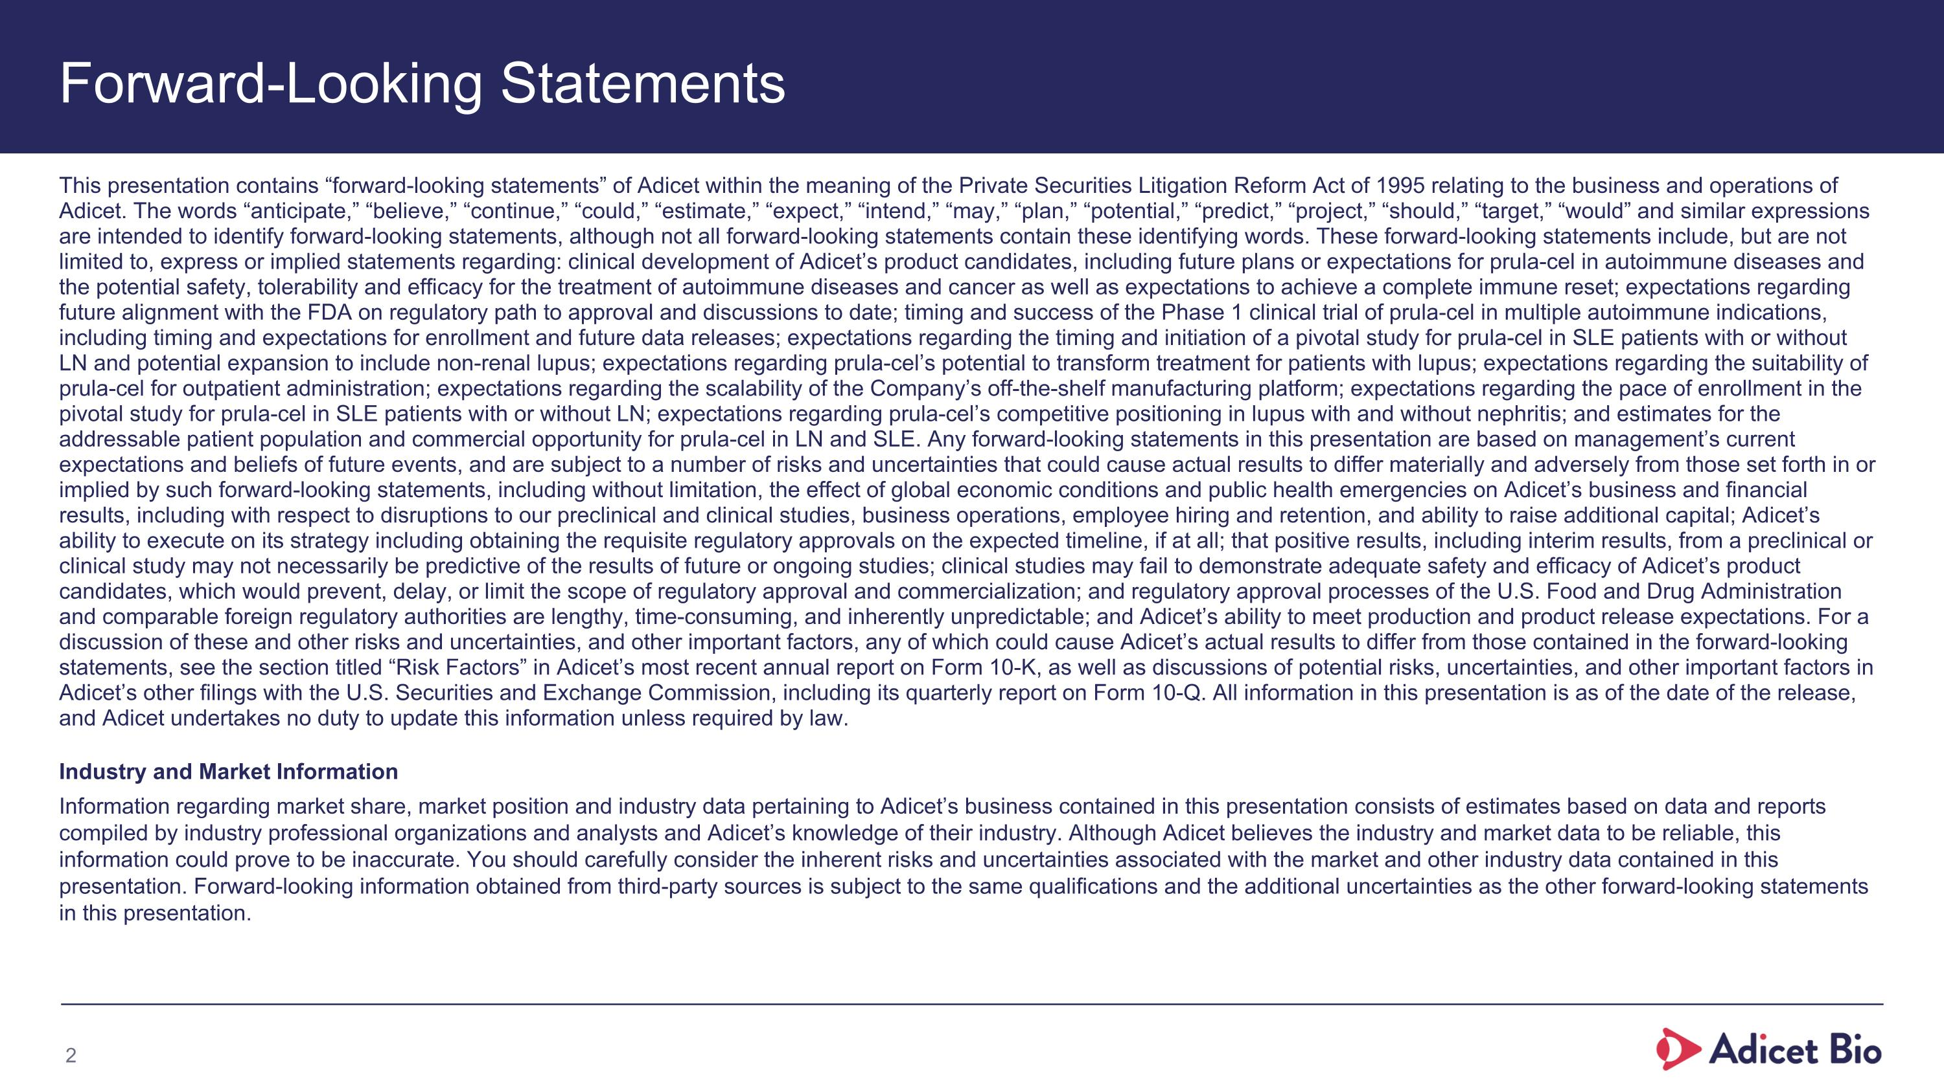
Forward-Looking Statements This presentation contains “forward-looking statements” of Adicet within the meaning of the Private Securities Litigation Reform Act of 1995 relating to the business and operations of Adicet. The words “anticipate,” “believe,” “continue,” “could,” “estimate,” “expect,” “intend,” “may,” “plan,” “potential,” “predict,” “project,” “should,” “target,” “would” and similar expressions are intended to identify forward-looking statements, although not all forward-looking statements contain these identifying words. These forward-looking statements include, but are not limited to, express or implied statements regarding: clinical development of Adicet’s product candidates, including future plans or expectations for prula-cel in autoimmune diseases and the potential safety, tolerability and efficacy for the treatment of autoimmune diseases and cancer as well as expectations to achieve a complete immune reset; expectations regarding future alignment with the FDA on regulatory path to approval and discussions to date; timing and success of the Phase 1 clinical trial of prula-cel in multiple autoimmune indications, including timing and expectations for enrollment and future data releases; expectations regarding the timing and initiation of a pivotal study for prula-cel in SLE patients with or without LN and potential expansion to include non-renal lupus; expectations regarding prula-cel’s potential to transform treatment for patients with lupus; expectations regarding the suitability of prula-cel for outpatient administration; expectations regarding the scalability of the Company’s off-the-shelf manufacturing platform; expectations regarding the pace of enrollment in the pivotal study for prula-cel in SLE patients with or without LN; expectations regarding prula-cel’s competitive positioning in lupus with and without nephritis; and estimates for the addressable patient population and commercial opportunity for prula-cel in LN and SLE. Any forward-looking statements in this presentation are based on management’s current expectations and beliefs of future events, and are subject to a number of risks and uncertainties that could cause actual results to differ materially and adversely from those set forth in or implied by such forward-looking statements, including without limitation, the effect of global economic conditions and public health emergencies on Adicet’s business and financial results, including with respect to disruptions to our preclinical and clinical studies, business operations, employee hiring and retention, and ability to raise additional capital; Adicet’s ability to execute on its strategy including obtaining the requisite regulatory approvals on the expected timeline, if at all; that positive results, including interim results, from a preclinical or clinical study may not necessarily be predictive of the results of future or ongoing studies; clinical studies may fail to demonstrate adequate safety and efficacy of Adicet’s product candidates, which would prevent, delay, or limit the scope of regulatory approval and commercialization; and regulatory approval processes of the U.S. Food and Drug Administration and comparable foreign regulatory authorities are lengthy, time-consuming, and inherently unpredictable; and Adicet’s ability to meet production and product release expectations. For a discussion of these and other risks and uncertainties, and other important factors, any of which could cause Adicet’s actual results to differ from those contained in the forward-looking statements, see the section titled “Risk Factors” in Adicet’s most recent annual report on Form 10-K, as well as discussions of potential risks, uncertainties, and other important factors in Adicet’s other filings with the U.S. Securities and Exchange Commission, including its quarterly report on Form 10-Q. All information in this presentation is as of the date of the release, and Adicet undertakes no duty to update this information unless required by law. Industry and Market Information Information regarding market share, market position and industry data pertaining to Adicet’s business contained in this presentation consists of estimates based on data and reports compiled by industry professional organizations and analysts and Adicet’s knowledge of their industry. Although Adicet believes the industry and market data to be reliable, this information could prove to be inaccurate. You should carefully consider the inherent risks and uncertainties associated with the market and other industry data contained in this presentation. Forward-looking information obtained from third-party sources is subject to the same qualifications and the additional uncertainties as the other forward-looking statements in this presentation.

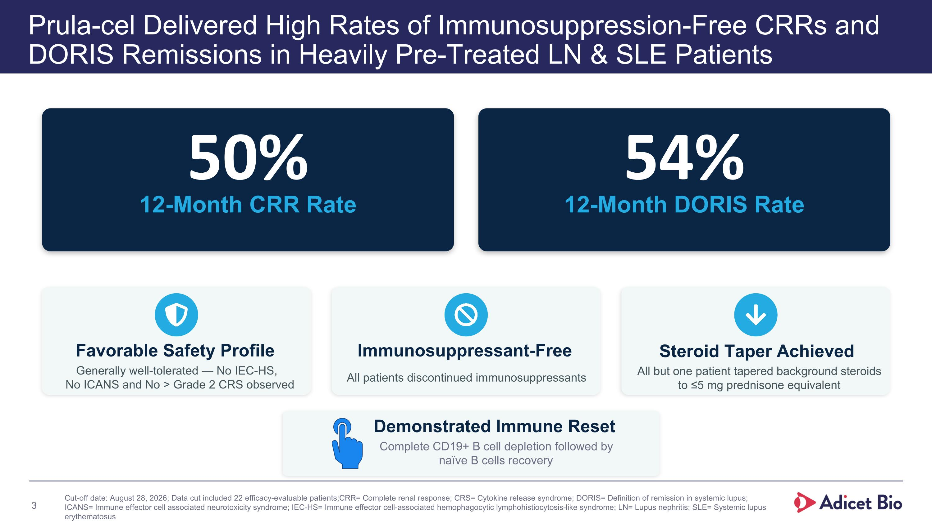
Prula-cel Delivered High Rates of Immunosuppression-Free CRRs and DORIS Remissions in Heavily Pre-Treated LN & SLE Patients 50% 12-Month CRR Rate 54% 12-Month DORIS Rate Favorable Safety Profile Generally well-tolerated — No IEC-HS, No ICANS and No > Grade 2 CRS observed Immunosuppressant-Free All patients discontinued immunosuppressants Steroid Taper Achieved All but one patient tapered background steroids to ≤5 mg prednisone equivalent Cut-off date: August 28, 2026; Data cut included 22 efficacy-evaluable patients; CRR= Complete renal response; CRS= Cytokine release syndrome; DORIS= Definition of remission in systemic lupus; ICANS= Immune effector cell associated neurotoxicity syndrome; IEC-HS= Immune effector cell-associated hemophagocytic lymphohistiocytosis-like syndrome; LN= Lupus nephritis; SLE= Systemic lupus erythematosus Demonstrated Immune Reset Complete CD19+ B cell depletion followed by naïve B cells recovery

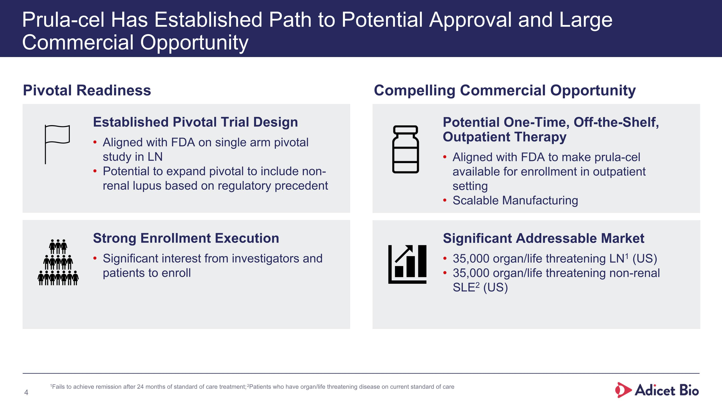
Potential One-Time, Off-the-Shelf, Outpatient Therapy Aligned with FDA to make prula-cel available for enrollment in outpatient setting Scalable Manufacturing Significant Addressable Market 35,000 organ/life threatening LN1 (US) 35,000 organ/life threatening non-renal SLE2 (US) Strong Enrollment Execution Significant interest from investigators and ?patients to enroll Established Pivotal Trial Design Aligned with FDA on single arm pivotal study in LN Potential to expand pivotal to include non-renal lupus based on regulatory precedent Prula-cel Has Established Path to Potential Approval and Large Commercial Opportunity 1Fails to achieve remission after 24 months of standard of care treatment; 2Patients who have organ/life threatening disease on current standard of care Pivotal Readiness Compelling Commercial Opportunity

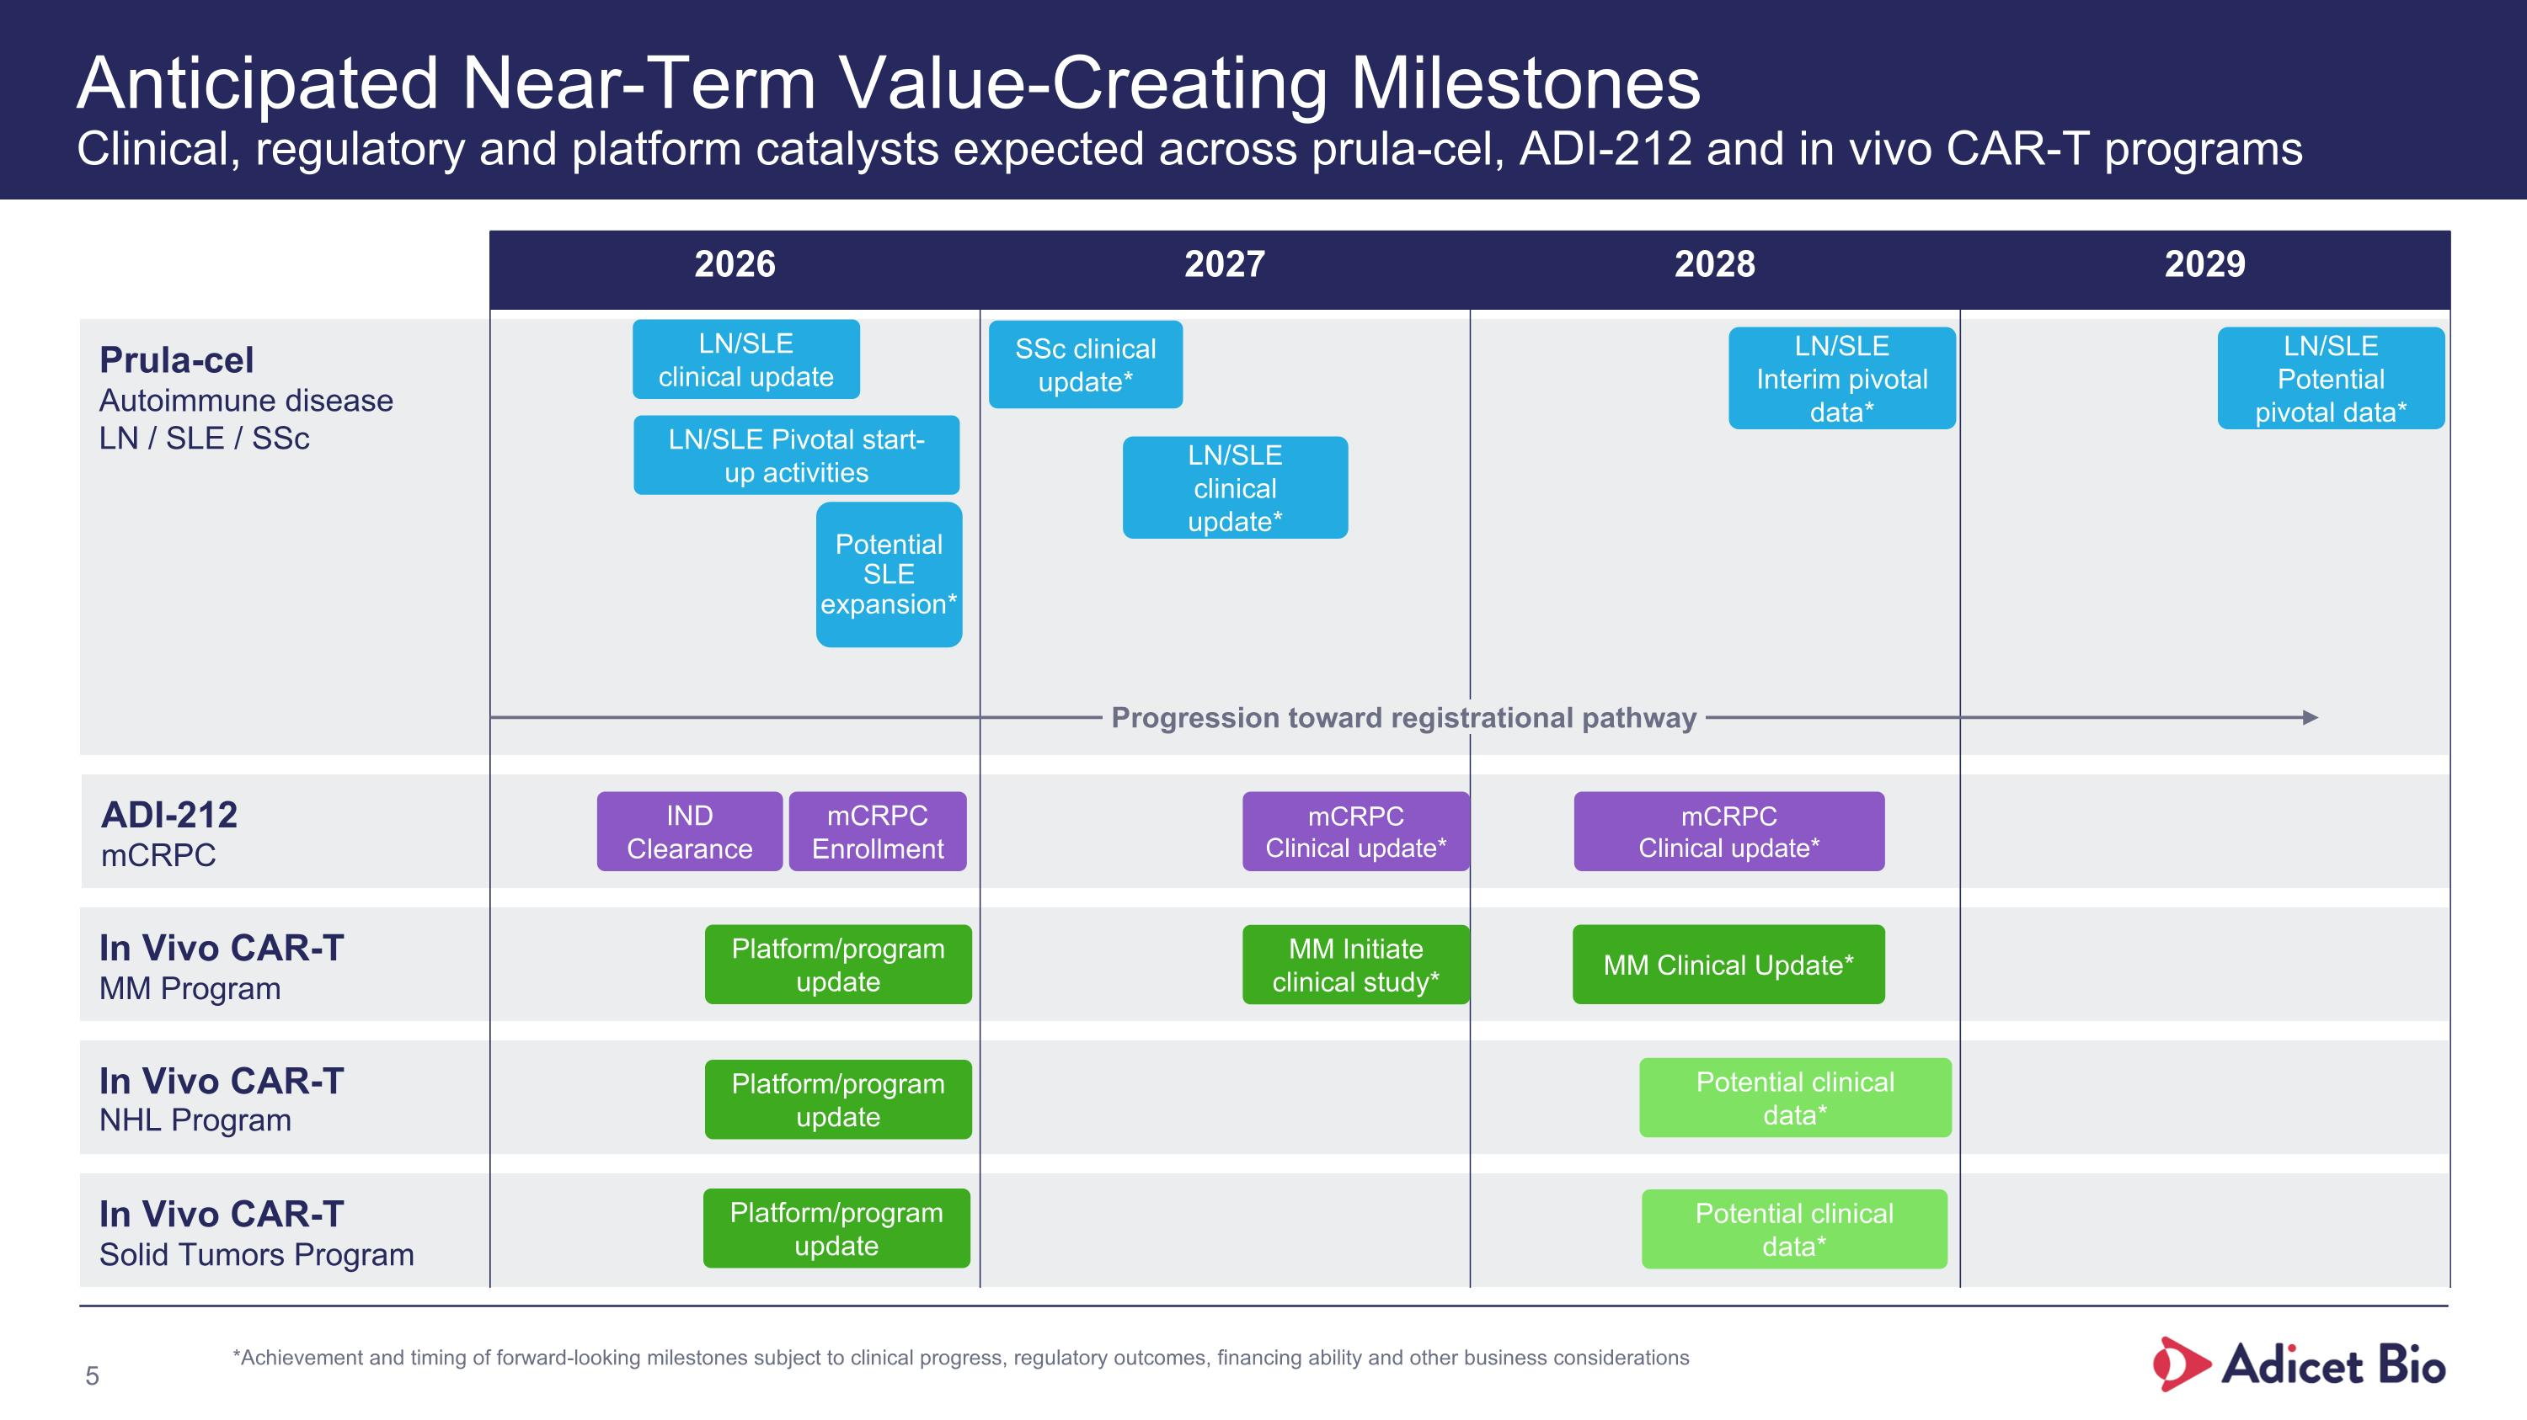
Anticipated Near-Term Value-Creating Milestones?Clinical, regulatory and platform catalysts expected across prula-cel, ADI-212 and in vivo CAR-T programs Prula-cel Autoimmune disease LN / SLE / SSc ADI-212 mCRPC In Vivo CAR-T MM Program In Vivo CAR-T NHL Program In Vivo CAR-T Solid Tumors Program 2026 2027 2028 2029 Progression toward registrational pathway Potential clinical data* Potential clinical data* MM Initiate clinical study* mCRPC Clinical update* SSc clinical update* LN/SLE clinical update LN/SLE clinical update* LN/SLE Pivotal start-up activities mCRPC Enrollment Potential SLE expansion* IND Clearance LN/SLE Interim pivotal data* LN/SLE Potential pivotal data* *Achievement and timing of forward-looking milestones subject to clinical progress, regulatory outcomes, financing ability and other business considerations Platform/program update Platform/program update Platform/program update MM Clinical Update* mCRPC Clinical update*

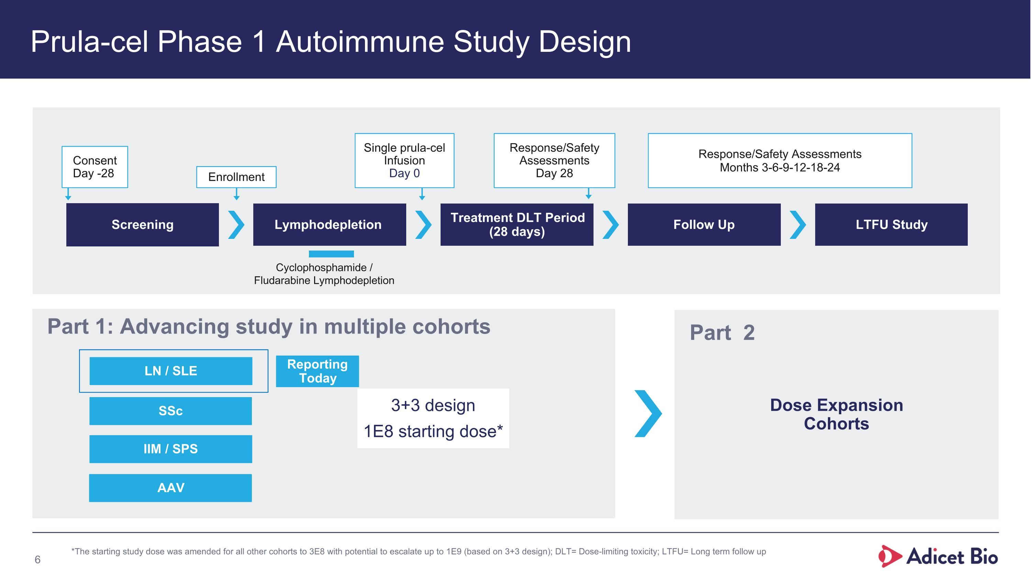
Prula-cel Phase 1 Autoimmune Study Design Screening Lymphodepletion Treatment DLT Period (28 days) Follow Up LTFU Study Consent Day -28 Enrollment Single prula-cel Infusion Day 0 Response/Safety Assessments Day 28 Response/Safety Assessments Months 3-6-9-12-18-24 Cyclophosphamide / ?Fludarabine Lymphodepletion SSc LN / SLE Part 1: Advancing study in multiple cohorts Dose Expansion?Cohorts Part 2 *The starting study dose was amended for all other cohorts to 3E8 with potential to escalate up to 1E9 (based on 3+3 design); DLT= Dose-limiting toxicity; LTFU= Long term follow up 3+3 design 1E8 starting dose* IIM / SPS AAV Reporting Today

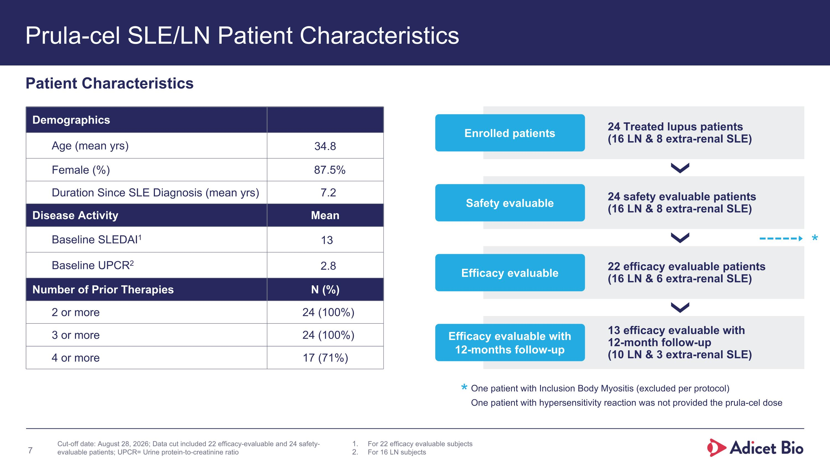
Prula-cel SLE/LN Patient Characteristics 24 Treated lupus patients?(16 LN & 8 extra-renal SLE) Enrolled patients 24 safety evaluable patients ?(16 LN & 8 extra-renal SLE) Safety evaluable 22 efficacy evaluable patients ?(16 LN & 6 extra-renal SLE) Efficacy evaluable 13 efficacy evaluable with ?12-month follow-up ?(10 LN & 3 extra-renal SLE) Efficacy evaluable with 12-months follow-up Patient Characteristics For 22 efficacy evaluable subjects For 16 LN subjects One patient with Inclusion Body Myositis (excluded per protocol) One patient with hypersensitivity reaction was not provided the prula-cel dose * * Cut-off date: August 28, 2026; Data cut included 22 efficacy-evaluable and 24 safety-evaluable patients; UPCR= Urine protein-to-creatinine ratio Demographics Age (mean yrs) 34.8 Female (%) 87.5% Duration Since SLE Diagnosis (mean yrs) 7.2 Disease Activity Mean Baseline SLEDAI1 13 Baseline UPCR2 2.8 Number of Prior Therapies N (%) 2 or more 24 (100%) 3 or more 24 (100%) 4 or more 17 (71%)

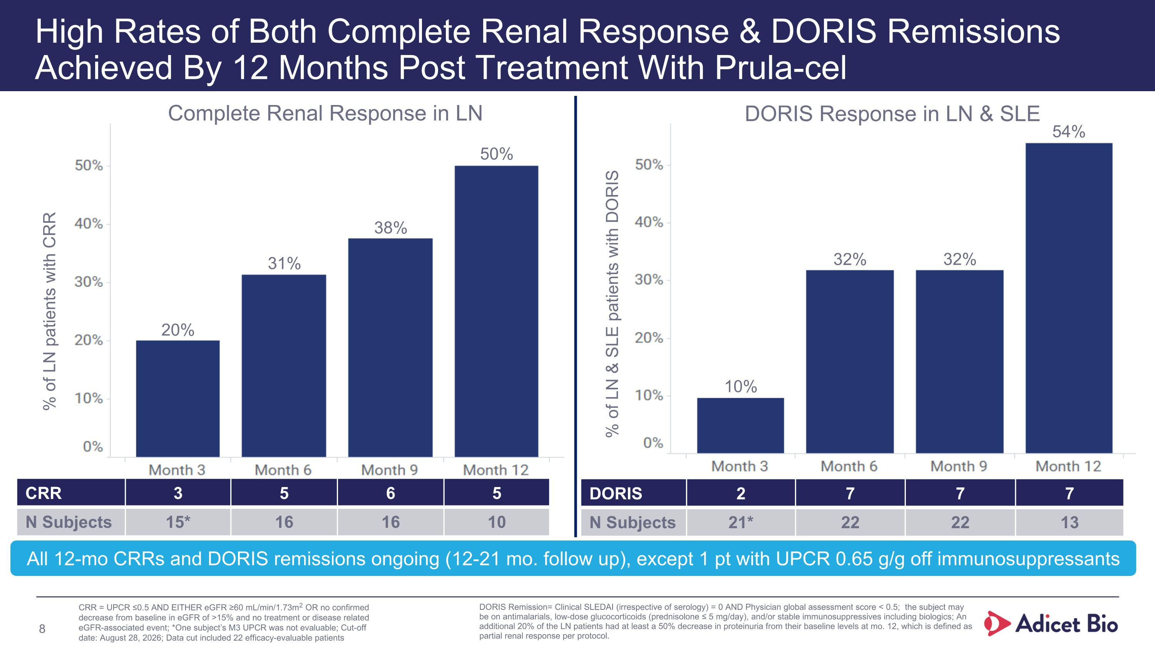
High Rates of Both Complete Renal Response & DORIS Remissions Achieved By 12 Months Post Treatment With Prula-cel CRR 3 5 6 5 N Subjects 15* 16 16 10 DORIS 2 7 7 7 N Subjects 21* 22 22 13 DORIS Response in LN & SLE Complete Renal Response in LN % of LN patients with CRR % of LN & SLE patients with DORIS CRR = UPCR ≤0.5 AND EITHER eGFR ≥60 mL/min/1.73m2 OR no confirmed decrease from baseline in eGFR of >15% and no treatment or disease related eGFR-associated event; *One subject’s M3 UPCR was not evaluable; Cut-off date: August 28, 2026; Data cut included 22 efficacy-evaluable patients DORIS Remission= Clinical SLEDAI (irrespective of serology) = 0 AND Physician global assessment score < 0.5; the subject may be on antimalarials, low-dose glucocorticoids (prednisolone ≤ 5 mg/day), and/or stable immunosuppressives including biologics; An additional 20% of the LN patients had at least a 50% decrease in proteinuria from their baseline levels at mo. 12, which is defined as partial renal response per protocol. 50% 38% 31% 20% 54% 32% 32% 10% All 12-mo CRRs and DORIS remissions ongoing (12-21 mo. follow up), except 1 pt with UPCR 0.65 g/g off immunosuppressants

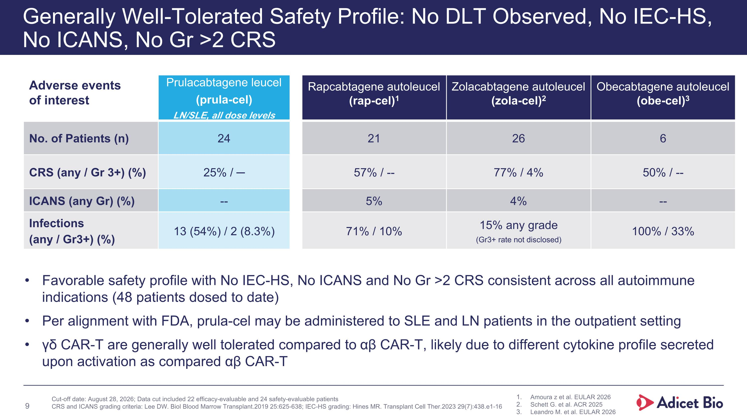
Prulacabtagene leucel (prula-cel) LN/SLE, all dose levels Rapcabtagene autoleucel (rap-cel)1 Zolacabtagene autoleucel (zola-cel)2 Obecabtagene autoleucel (obe-cel)3 No. of Patients (n) 24 21 26 6 CRS (any / Gr 3+) (%) 25% / ─ 57% / -- 77% / 4% 50% / -- ICANS (any Gr) (%) -- 5% 4% -- Infections (any / Gr3+) (%) 13 (54%) / 2 (8.3%) 71% / 10% 15% any grade (Gr3+ rate not disclosed) 100% / 33% Generally Well-Tolerated Safety Profile: No DLT Observed, No IEC-HS, No ICANS, No Gr >2 CRS Adicet Bio Confidential Information Adverse events of interest Favorable safety profile with No IEC-HS, No ICANS and No Gr >2 CRS consistent across all autoimmune indications (48 patients dosed to date) Per alignment with FDA, prula-cel may be administered to SLE and LN patients in the outpatient setting γδ CAR-T are generally well tolerated compared to αβ CAR-T, likely due to different cytokine profile secreted upon activation as compared αβ CAR-T 9 Amoura z et al. EULAR 2026 Schett G. et al. ACR 2025 Leandro M. et al. EULAR 2026 Cut-off date: August 28, 2026; Data cut included 22 efficacy-evaluable and 24 safety-evaluable patients CRS and ICANS grading criteria: Lee DW. Biol Blood Marrow Transplant.2019 25:625-638; IEC-HS grading: Hines MR. Transplant Cell Ther.2023 29(7):438.e1-16

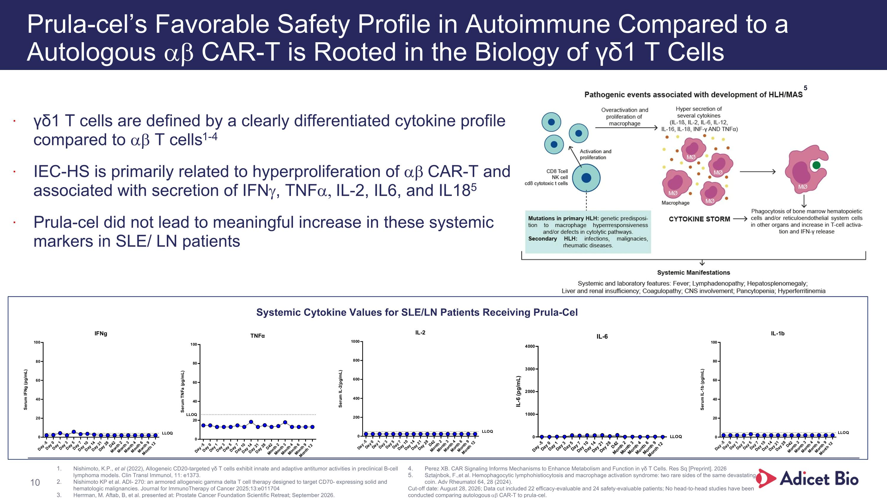
Prula-cel’s Favorable Safety Profile in Autoimmune Compared to a?Autologous ab CAR-T is Rooted in the Biology of γδ1 T Cells γδ1 T cells are defined by a clearly differentiated cytokine profile compared to ab T cells1-4 IEC-HS is primarily related to hyperproliferation of ab CAR-T and associated with secretion of IFNg, TNFa, IL-2, IL6, and IL185 Prula-cel did not lead to meaningful increase in these systemic markers in SLE/ LN patients Nishimoto, K.P., et al (2022), Allogeneic CD20-targeted γδ T cells exhibit innate and adaptive antitumor activities in preclinical B-cell lymphoma models. Clin Transl Immunol, 11: e1373. Nishimoto KP et al. ADI- 270: an armored allogeneic gamma delta T cell therapy designed to target CD70- expressing solid and hematologic malignancies. Journal for ImmunoTherapy of Cancer 2025;13:e011704 Herrman, M. Aftab, B, et al. presented at: Prostate Cancer Foundation Scientific Retreat; September 2026. Perez XB. CAR Signaling Informs Mechanisms to Enhance Metabolism and Function in γδ T Cells. Res Sq [Preprint]. 2026 Sztajnbok, F.,et al. Hemophagocytic lymphohistiocytosis and macrophage activation syndrome: two rare sides of the same devastating coin. Adv Rheumatol 64, 28 (2024). Cut-off date: August 28, 2026; Data cut included 22 efficacy-evaluable and 24 safety-evaluable patients; No head-to-head studies have been conducted comparing autologous ab CAR-T to prula-cel. 5 Systemic Cytokine Values for SLE/LN Patients Receiving Prula-Cel 10

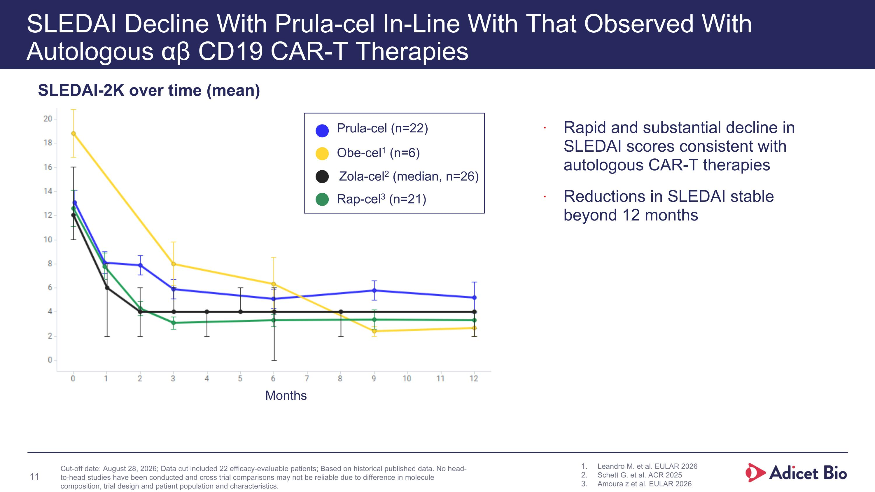
* Months SLEDAI Decline With Prula-cel In-Line With That Observed With Autologous αβ CD19 CAR-T Therapies Rapid and substantial decline in SLEDAI scores consistent with autologous CAR-T therapies Reductions in SLEDAI stable beyond 12 months SLEDAI-2K over time (mean) Leandro M. et al. EULAR 2026 Schett G. et al. ACR 2025 Amoura z et al. EULAR 2026 Cut-off date: August 28, 2026; Data cut included 22 efficacy-evaluable patients; Based on historical published data. No head-to-head studies have been conducted and cross trial comparisons may not be reliable due to difference in molecule composition, trial design and patient population and characteristics. 11 Zola-cel2 (median, n=26) Prula-cel (n=22) Obe-cel1 (n=6) Rap-cel3 (n=21)

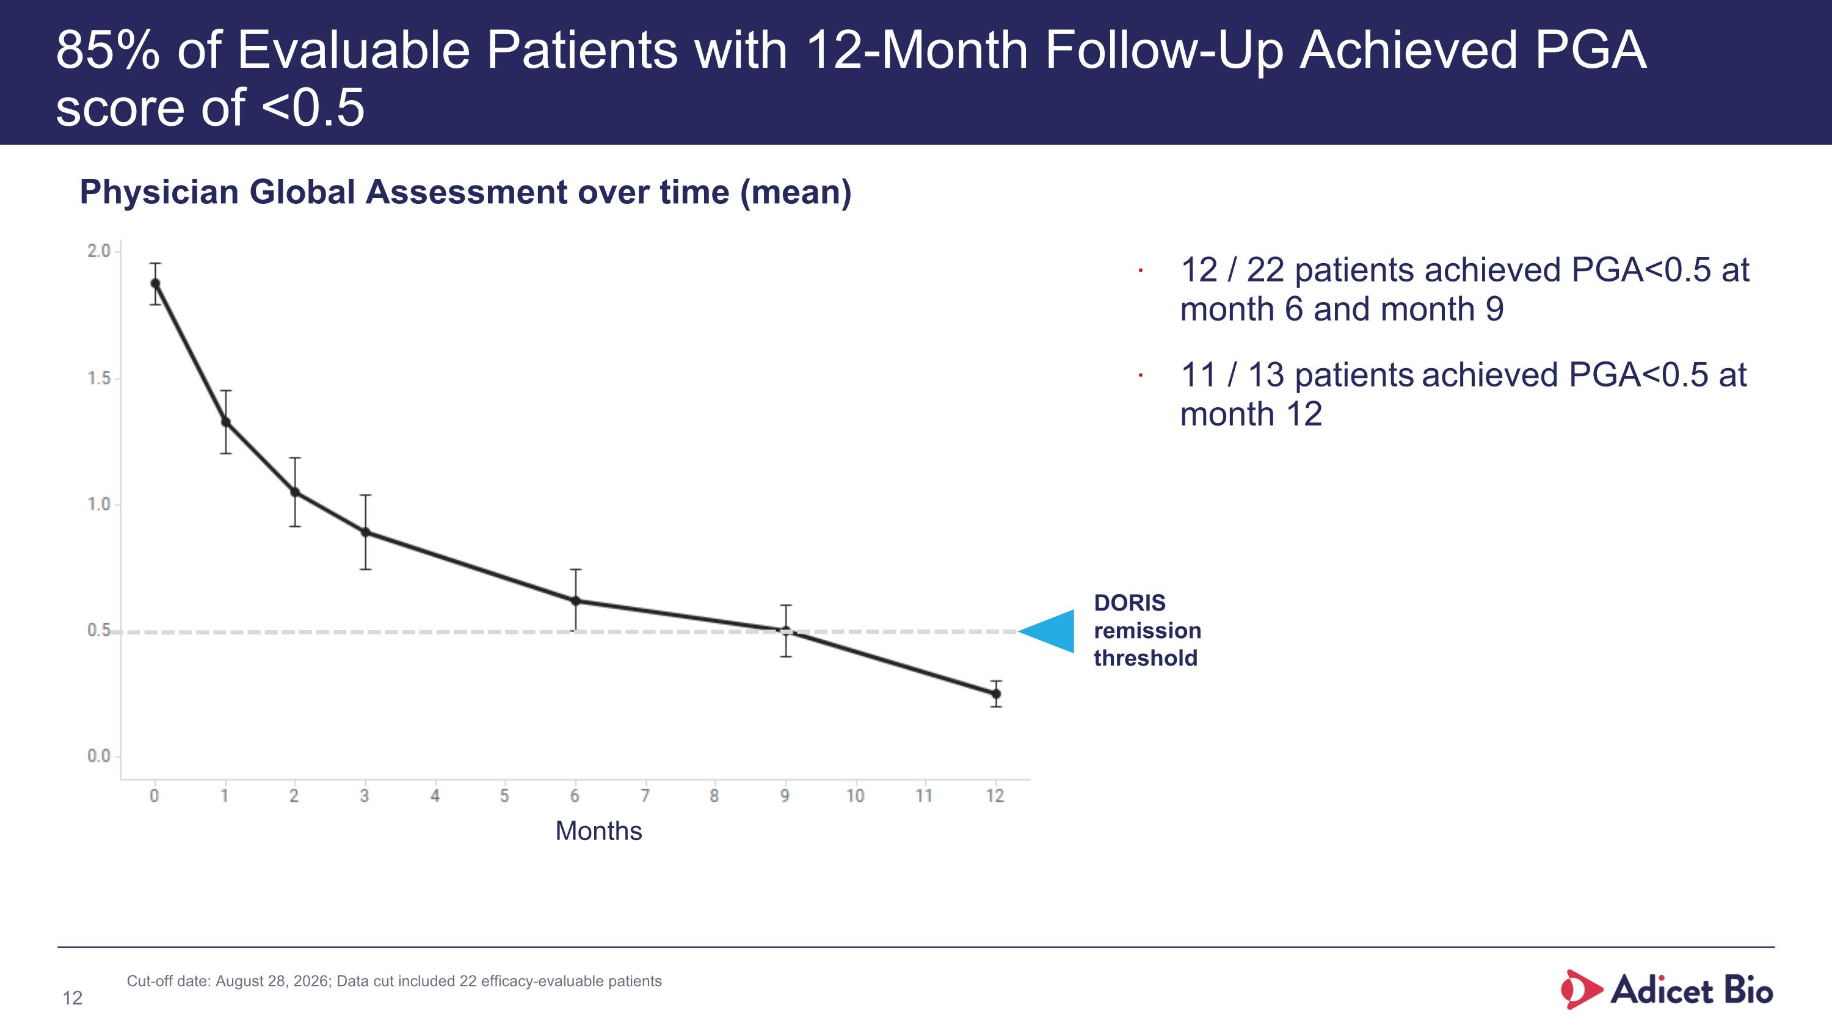
* Months 85% of Evaluable Patients with 12-Month Follow-Up Achieved PGA score of <0.5 12 / 22 patients achieved PGA<0.5 at month 6 and month 9 11 / 13 patients achieved PGA<0.5 at month 12 Physician Global Assessment over time (mean) 12 DORIS remission threshold Cut-off date: August 28, 2026; Data cut included 22 efficacy-evaluable patients

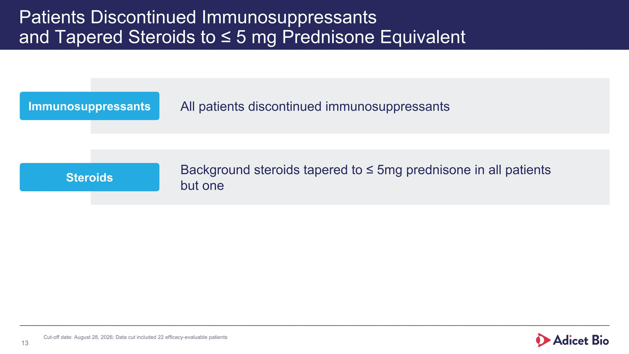
Patients Discontinued Immunosuppressants ?and Tapered Steroids to ≤ 5 mg Prednisone Equivalent All patients discontinued immunosuppressants Immunosuppressants Background steroids tapered to ≤ 5mg prednisone in all patients ?but one Steroids 13 Cut-off date: August 28, 2026; Data cut included 22 efficacy-evaluable patients

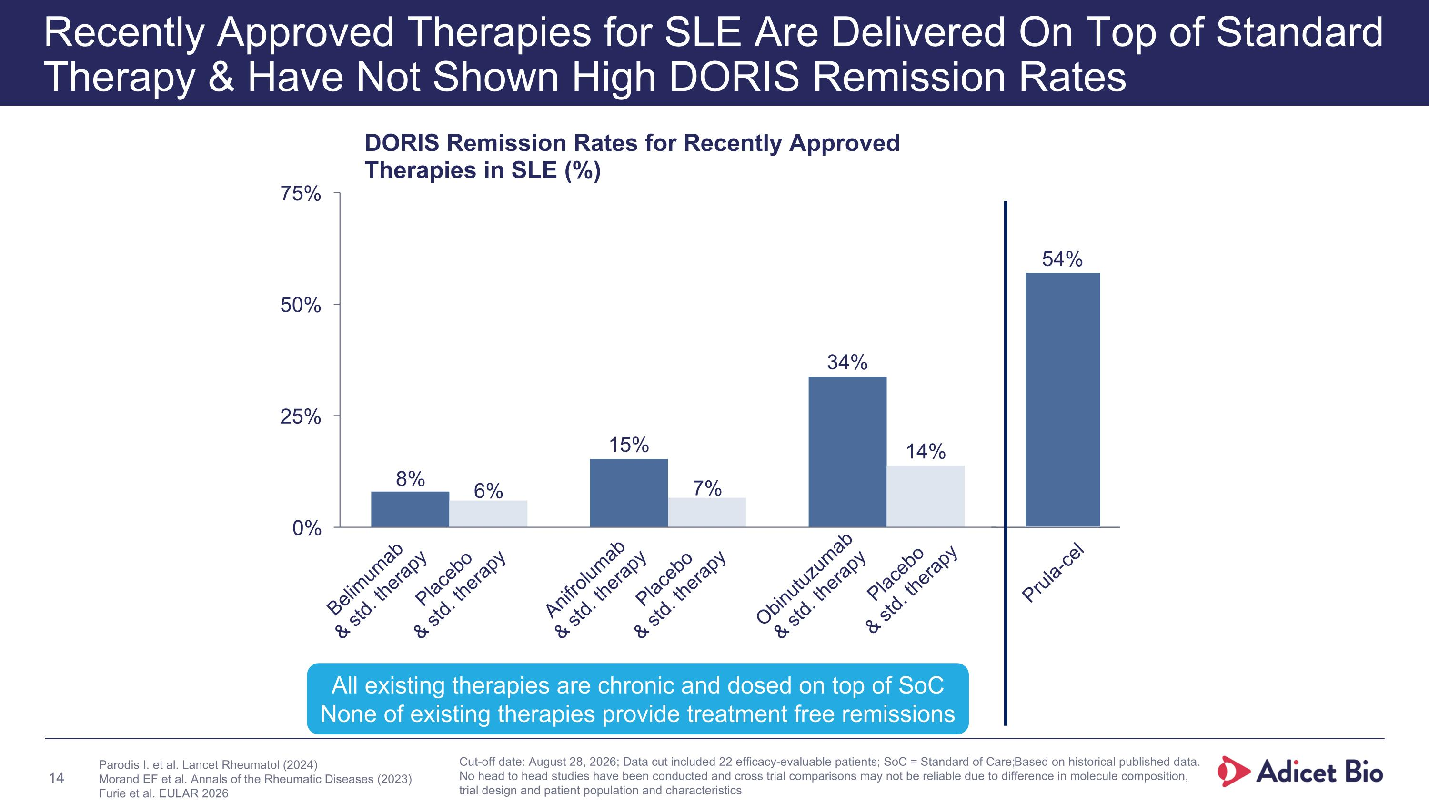
Recently Approved Therapies for SLE Are Delivered On Top of Standard Therapy & Have Not Shown High DORIS Remission Rates DORIS Remission Rates for Recently Approved Therapies in SLE (%) Belimumab & std. therapy Placebo & std. therapy Anifrolumab & std. therapy Placebo & std. therapy Obinutuzumab & std. therapy Placebo & std. therapy Parodis I. et al. Lancet Rheumatol (2024) Morand EF et al. Annals of the Rheumatic Diseases (2023) Furie et al. EULAR 2026 All existing therapies are chronic and dosed on top of SoC None of existing therapies provide treatment free remissions Prula-cel 54% 14 Cut-off date: August 28, 2026; Data cut included 22 efficacy-evaluable patients; SoC = Standard of Care; Based on historical published data. No head to head studies have been conducted and cross trial comparisons may not be reliable due to difference in molecule composition, trial design and patient population and characteristics

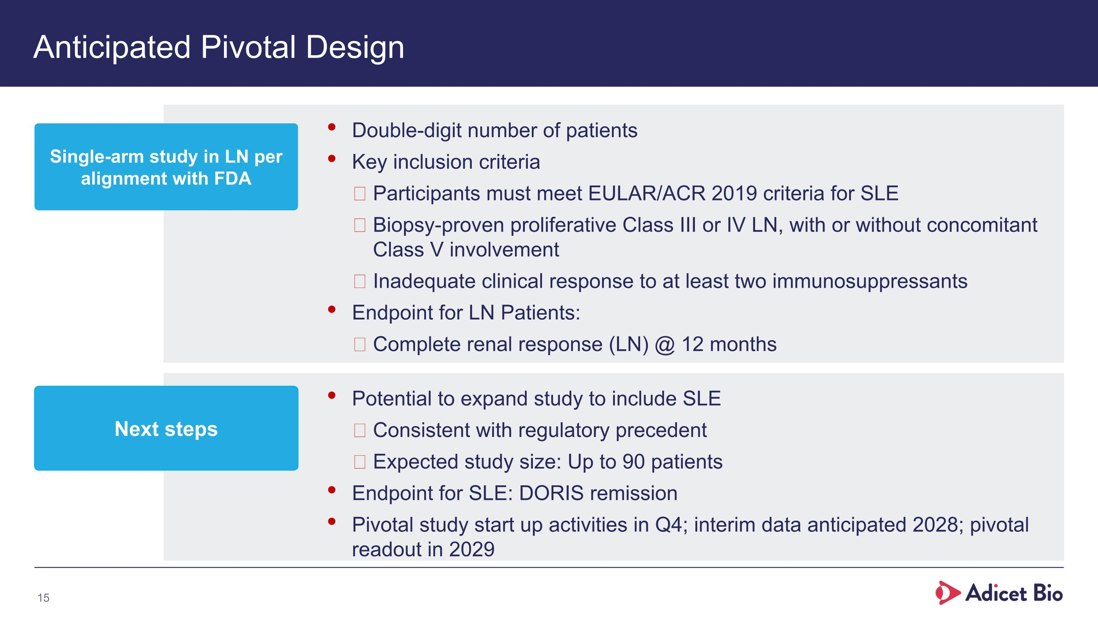
Anticipated Pivotal Design Double-digit number of patients Key inclusion criteria Participants must meet EULAR/ACR 2019 criteria for SLE Biopsy-proven proliferative Class III or IV LN, with or without concomitant Class V involvement Inadequate clinical response to at least two immunosuppressants Endpoint for LN Patients: Complete renal response (LN) @ 12 months Single-arm study in LN per alignment with FDA Potential to expand study to include SLE Consistent with regulatory precedent Expected study size: Up to 90 patients Endpoint for SLE: DORIS remission Pivotal study start up activities in Q4; interim data anticipated 2028; pivotal readout in 2029 Next steps 15

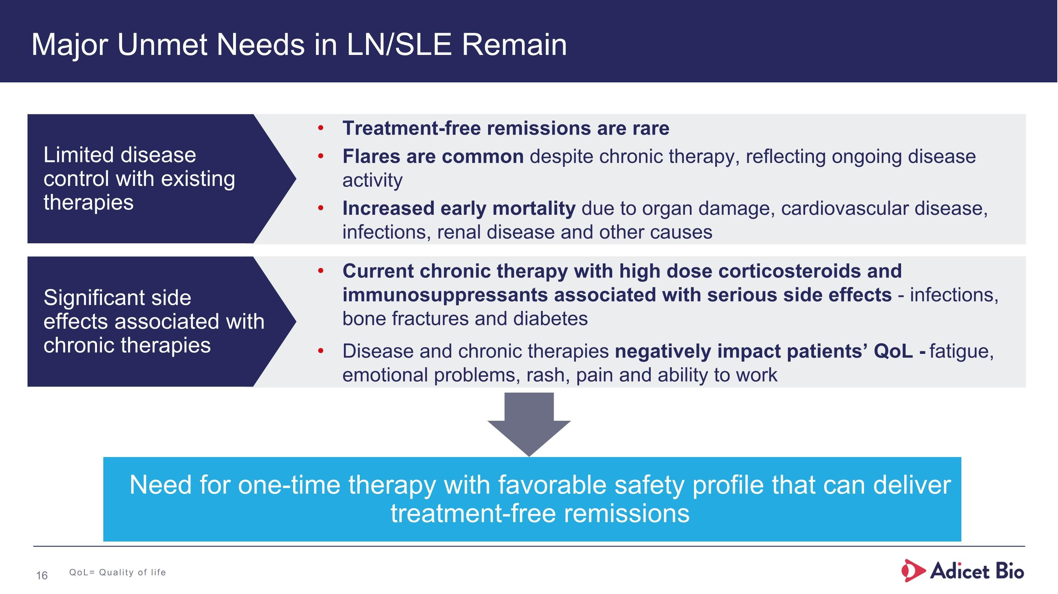
Major Unmet Needs in LN/SLE Remain Treatment-free remissions are rare Flares are common despite chronic therapy, reflecting ongoing disease activity Increased early mortality due to organ damage, cardiovascular disease, infections, renal disease and other causes Need for one-time therapy with favorable safety profile that can deliver treatment-free remissions Current chronic therapy with high dose corticosteroids and immunosuppressants associated with serious side effects - infections, bone fractures and diabetes Disease and chronic therapies negatively impact patients’ QoL - fatigue, emotional problems, rash, pain and ability to work Limited disease?control with existing therapies Significant side ?effects associated with chronic therapies QoL= Quality of life 16

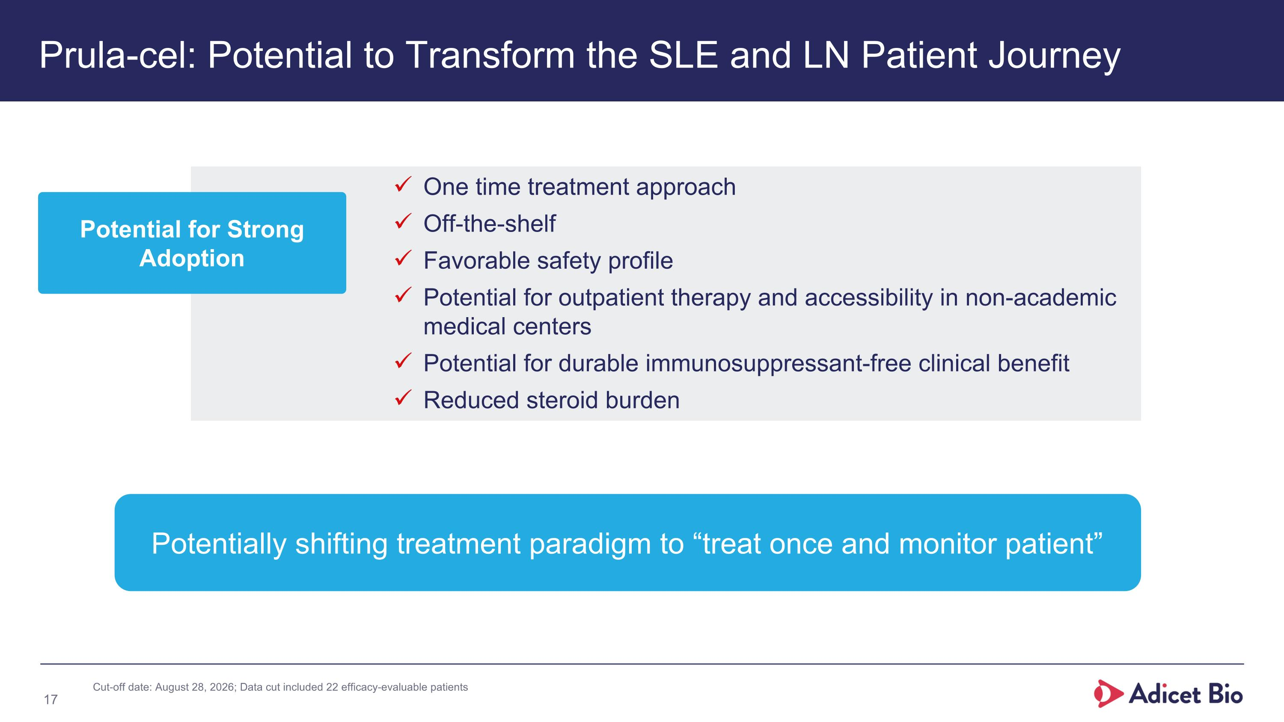
Prula-cel: Potential to Transform the SLE and LN Patient Journey One time treatment approach Off-the-shelf Favorable safety profile Potential for outpatient therapy and accessibility in non-academic medical centers Potential for durable immunosuppressant-free clinical benefit Reduced steroid burden Potentially shifting treatment paradigm to “treat once and monitor patient” 17 Cut-off date: August 28, 2026; Data cut included 22 efficacy-evaluable patients Potential for Strong Adoption

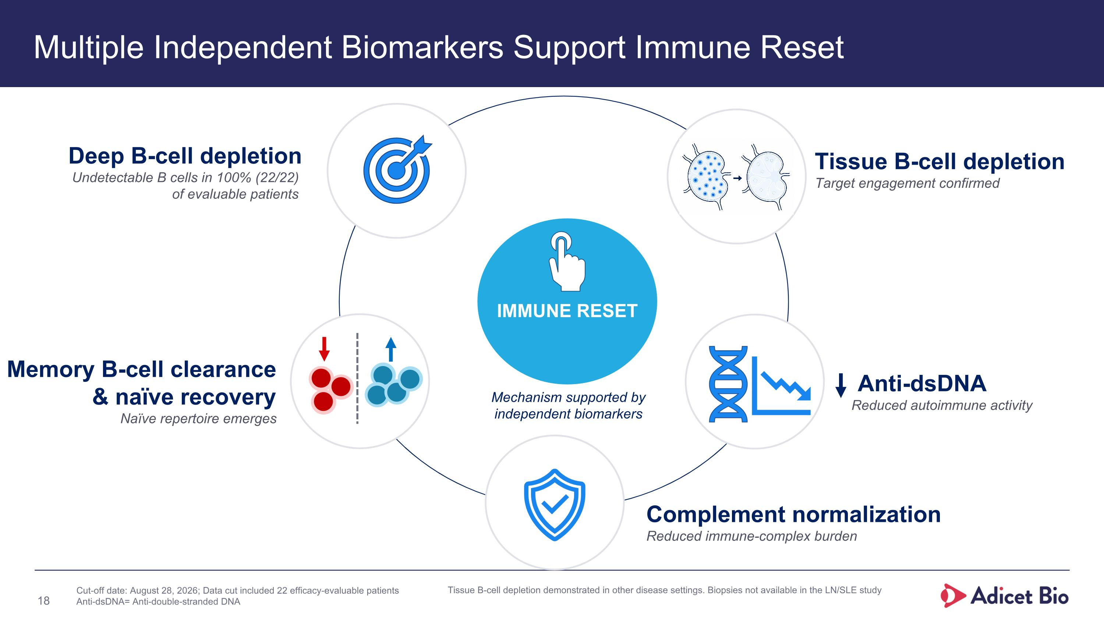
Multiple Independent Biomarkers Support Immune Reset IMMUNE RESET Memory B-cell clearance & naïve recovery Naïve repertoire emerges Deep B-cell depletion Undetectable B cells in 100% (22/22) of evaluable patients Tissue B-cell depletion Target engagement confirmed Complement normalization Reduced immune-complex burden Mechanism supported by independent biomarkers Anti-dsDNA Reduced autoimmune activity Cut-off date: August 28, 2026; Data cut included 22 efficacy-evaluable patients Anti-dsDNA= Anti-double-stranded DNA Tissue B-cell depletion demonstrated in other disease settings. Biopsies not available in the LN/SLE study 18

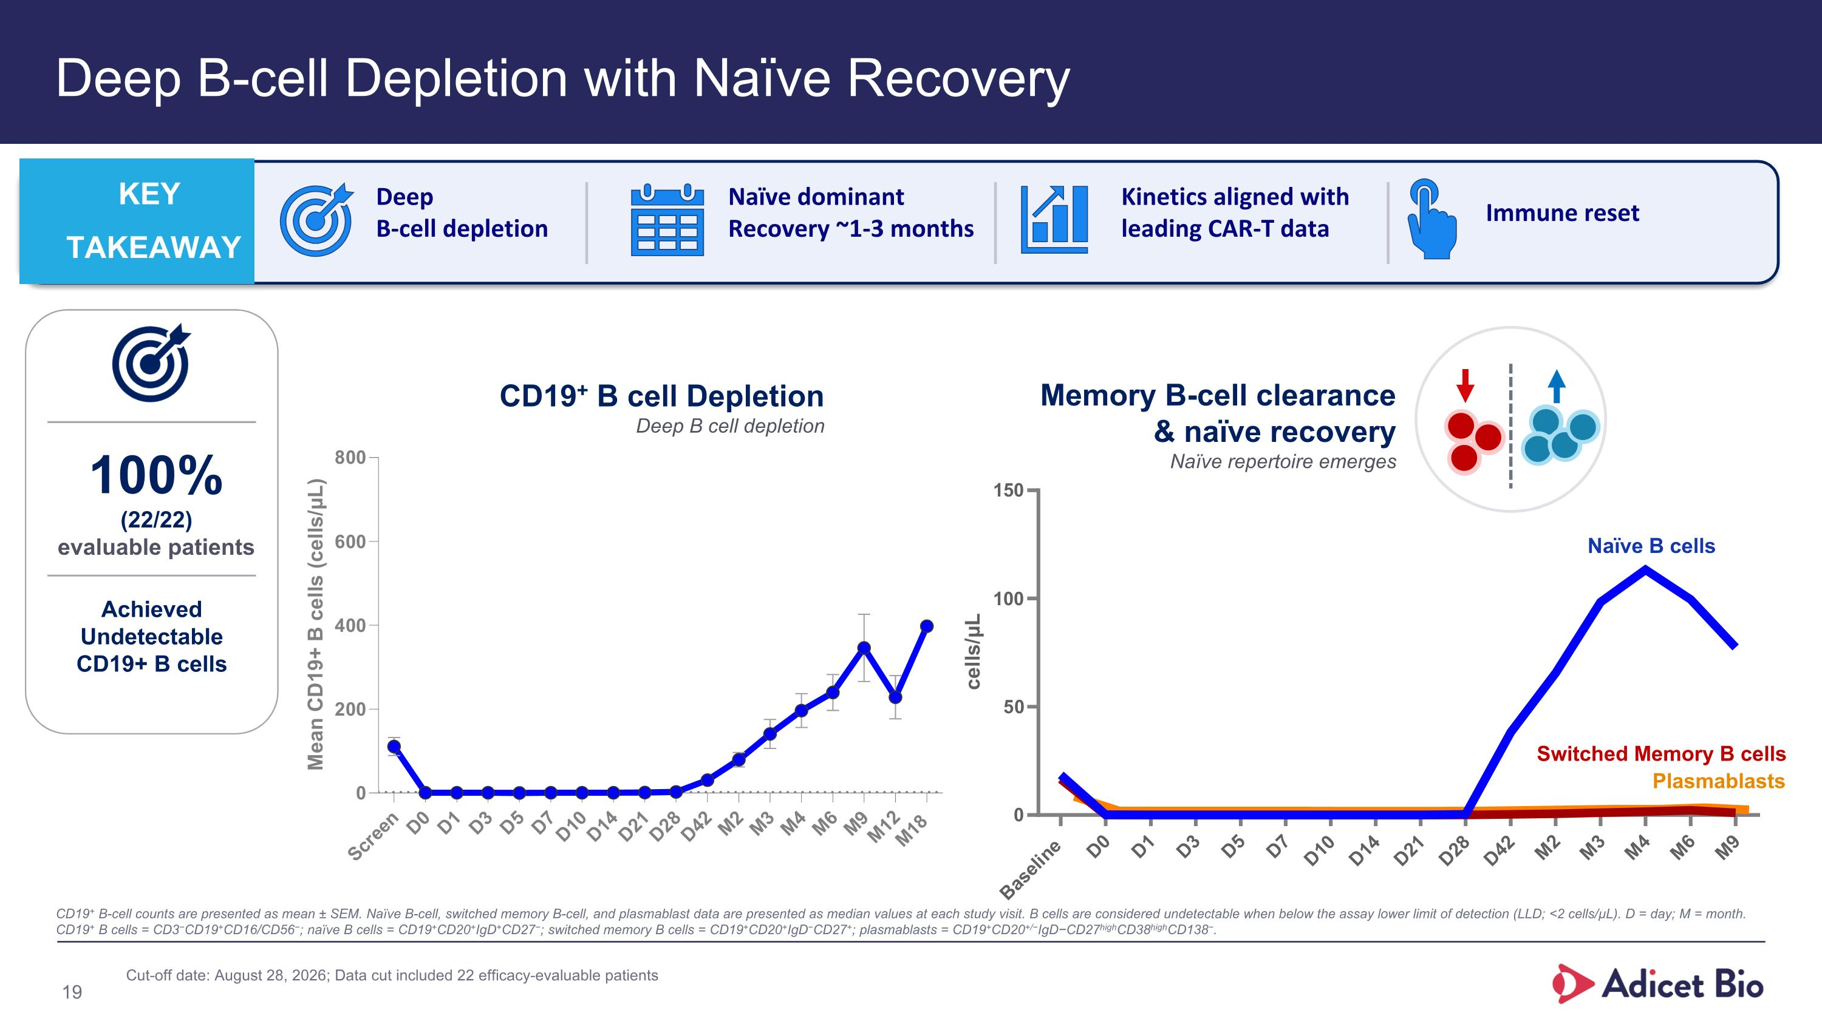
Deep B-cell Depletion with Naïve Recovery CD19+ B-cell counts are presented as mean ± SEM. Naïve B-cell, switched memory B-cell, and plasmablast data are presented as median values at each study visit. B cells are considered undetectable when below the assay lower limit of detection (LLD; <2 cells/µL). D = day; M = month. CD19+ B cells = CD3−CD19+CD16/CD56−; naïve B cells = CD19+CD20+IgD+CD27−; switched memory B cells = CD19+CD20+IgD−CD27+; plasmablasts = CD19+CD20+/−IgD−CD27highCD38highCD138−. Deep B-cell depletion KEY TAKEAWAY Naïve dominant Recovery ~1-3 months Kinetics aligned with leading CAR-T data Immune reset 100% (22/22) evaluable patients Achieved Undetectable CD19+ B cells Naïve B cells Memory B-cell clearance & naïve recovery Naïve repertoire emerges Switched Memory B cells Plasmablasts CD19+ B cell Depletion Deep B cell depletion 19 Cut-off date: August 28, 2026; Data cut included 22 efficacy-evaluable patients

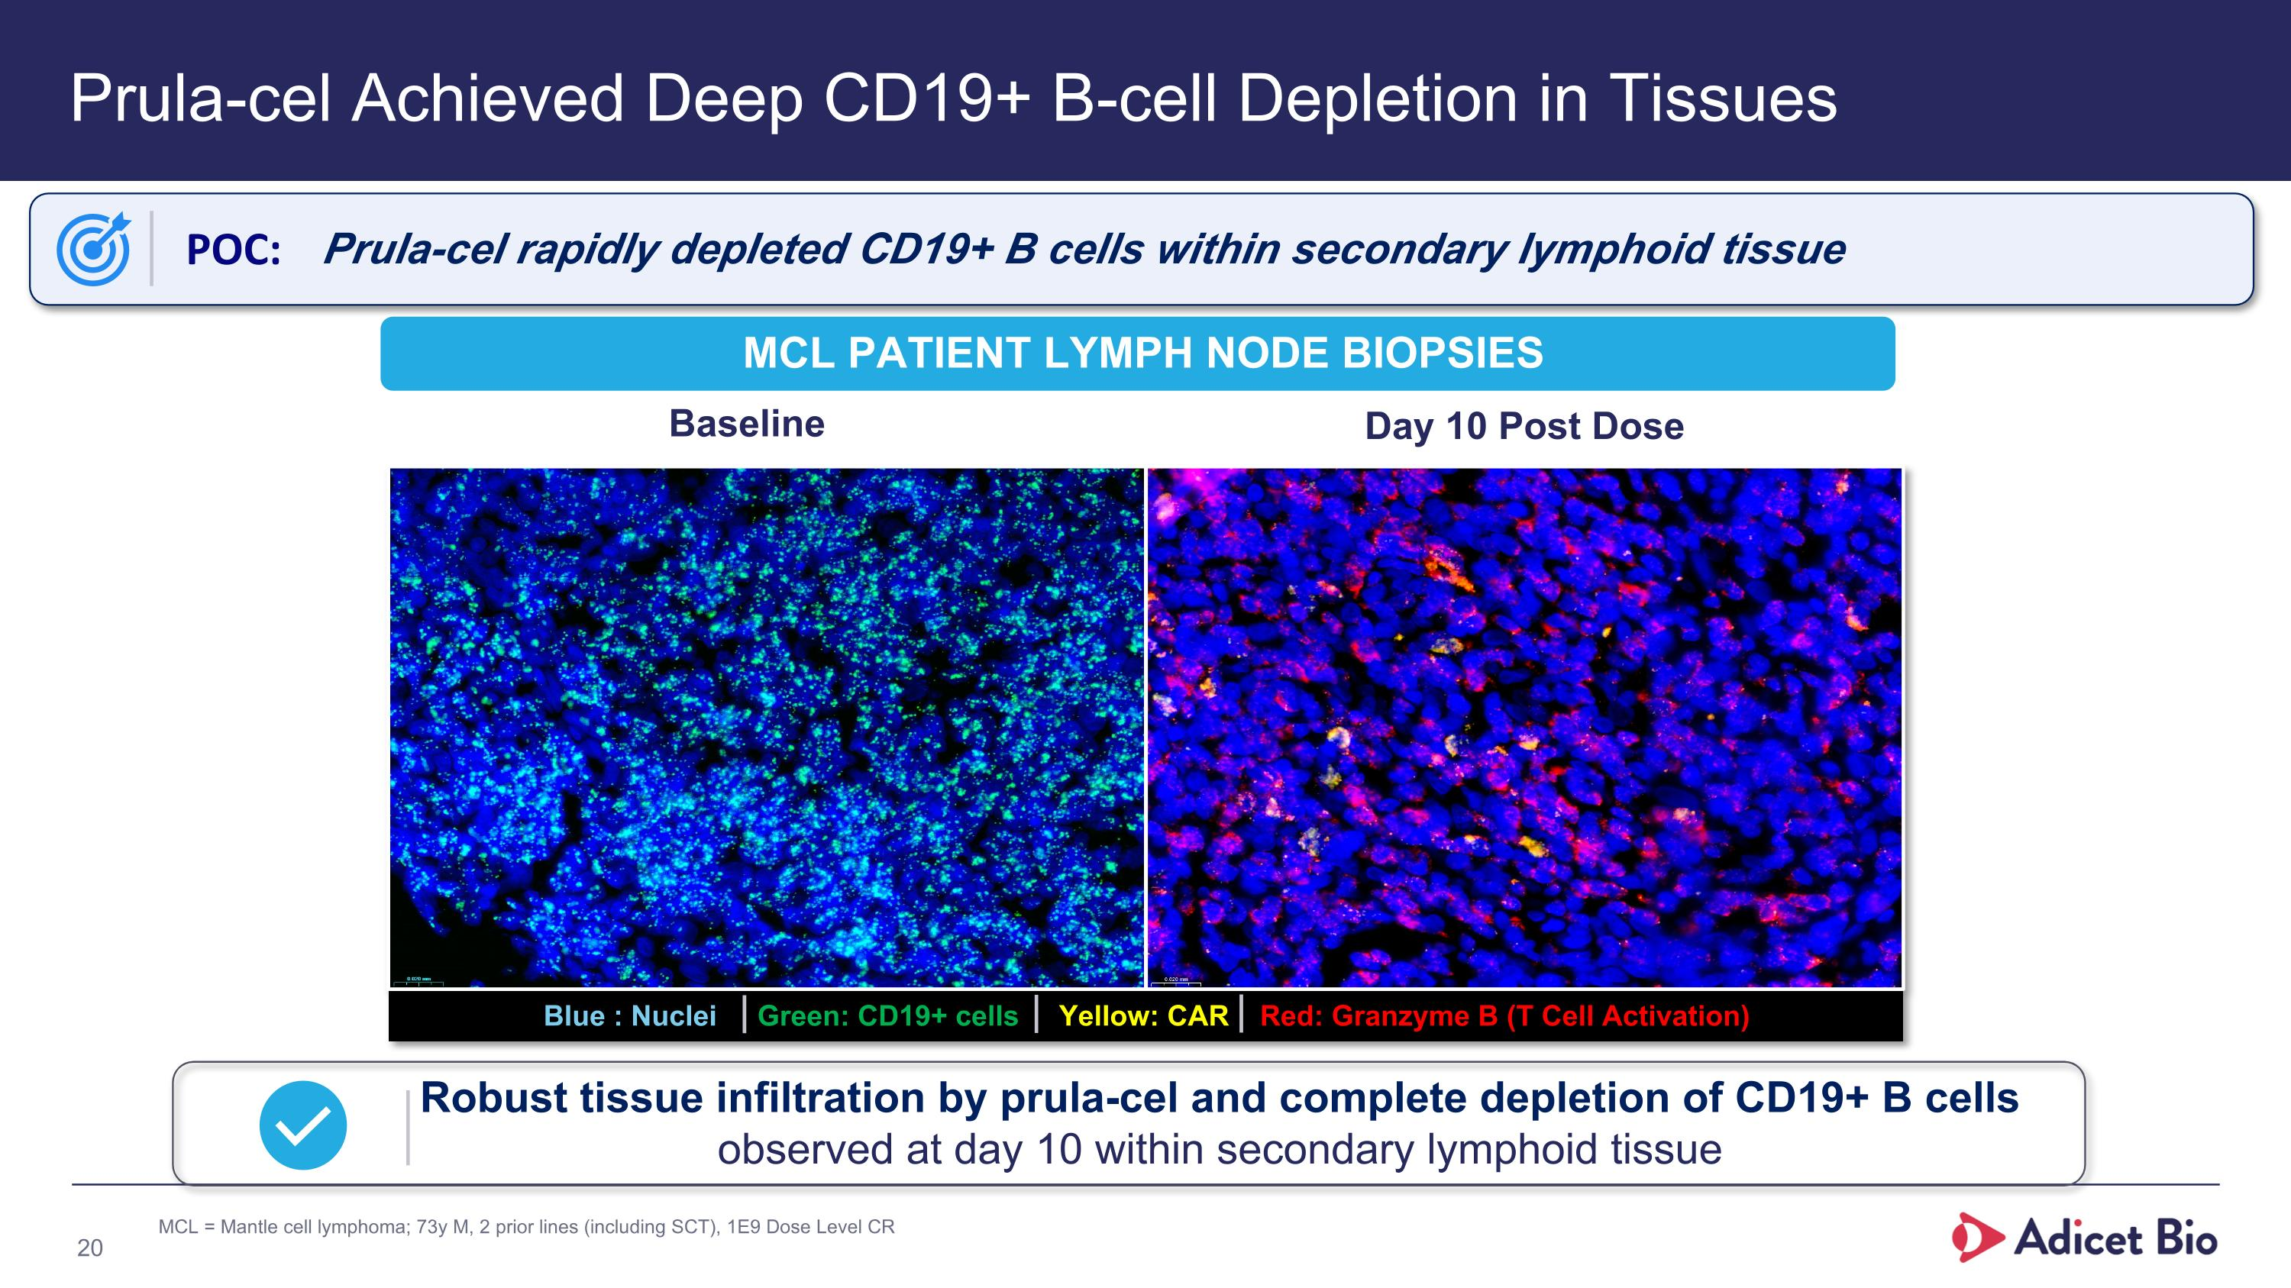
Prula-cel Achieved Deep CD19+ B-cell Depletion in Tissues Baseline Day 10 Post Dose Blue : Nuclei Green: CD19+ cells Yellow: CAR Red: Granzyme B (T Cell Activation) MCL Patient Lymph Node Biopsies POC: Prula-cel rapidly depleted CD19+ B cells within secondary lymphoid tissue Robust tissue infiltration by prula-cel and complete depletion of CD19+ B cells observed at day 10 within secondary lymphoid tissue 20 MCL = Mantle cell lymphoma; 73y M, 2 prior lines (including SCT), 1E9 Dose Level CR

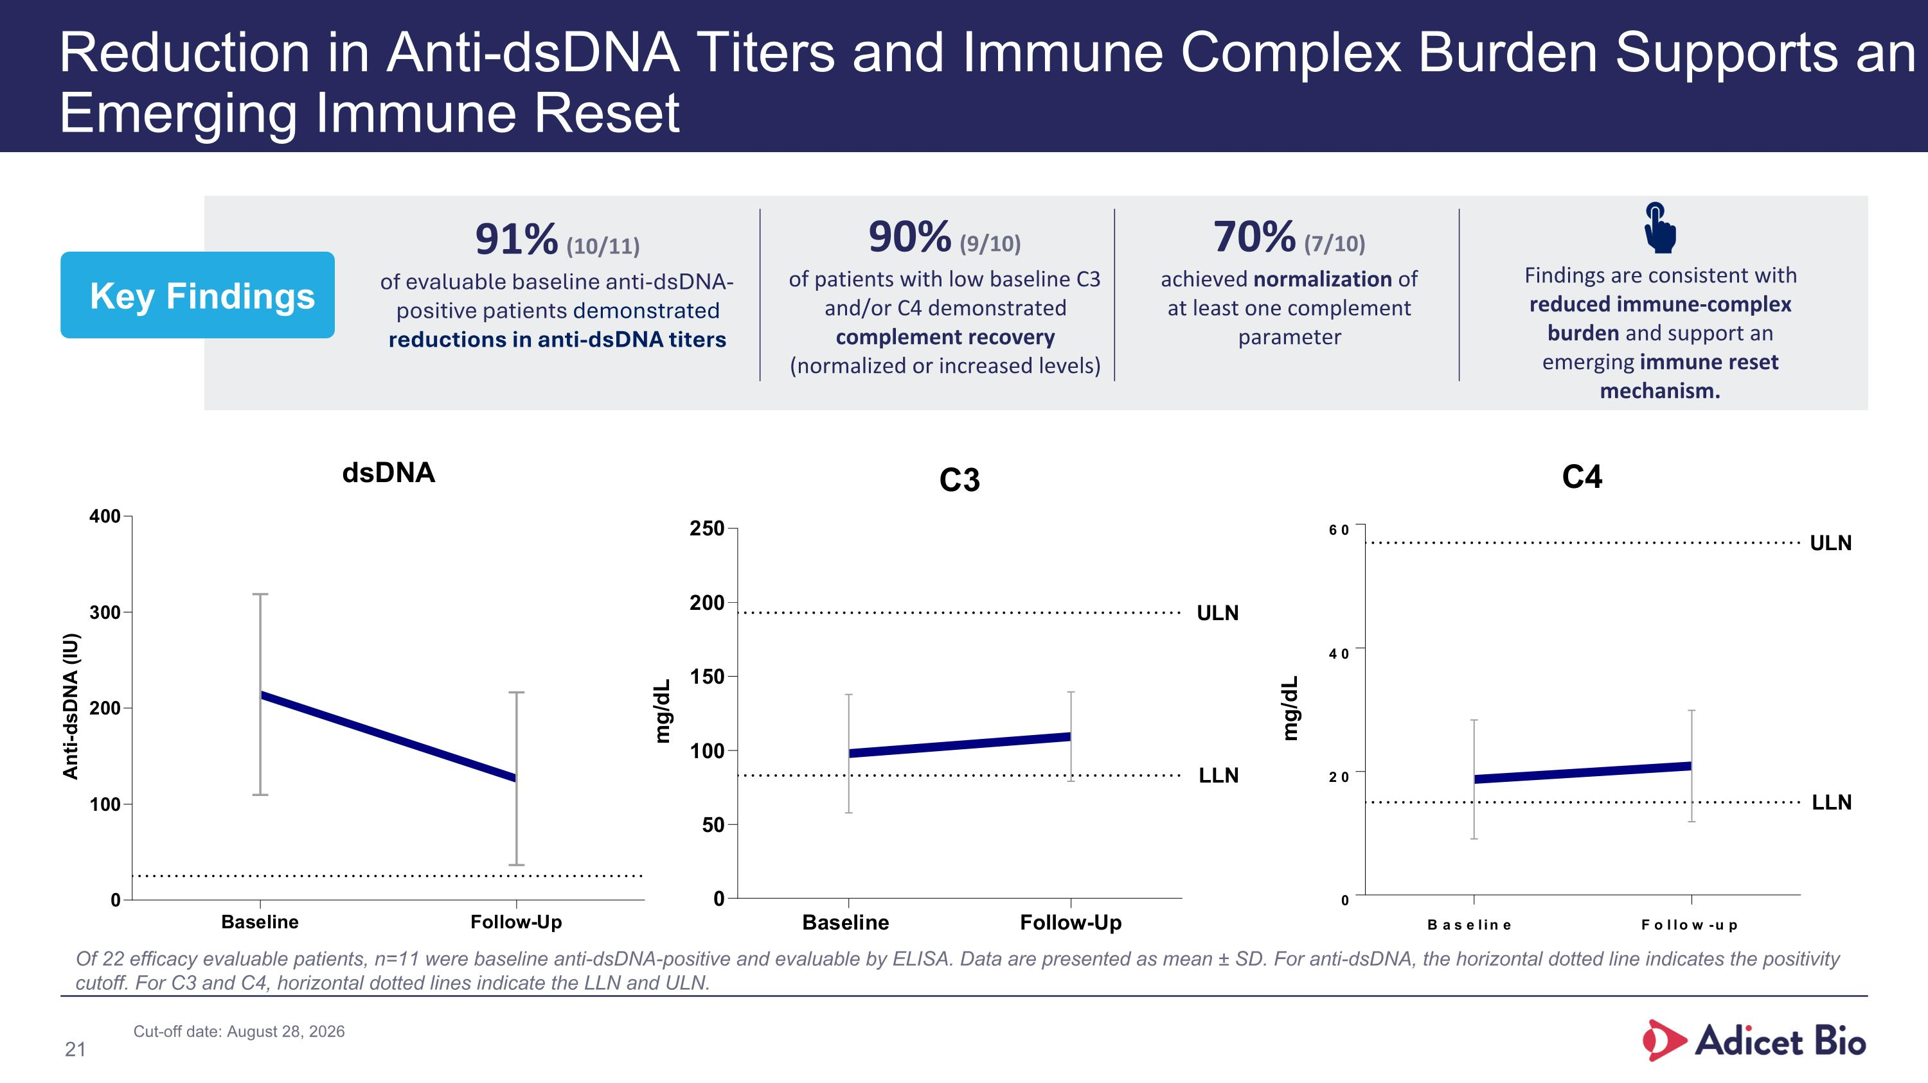
Reduction in Anti-dsDNA Titers and Immune Complex Burden Supports an Emerging Immune Reset Of 22 efficacy evaluable patients, n=11 were baseline anti-dsDNA-positive and evaluable by ELISA. Data are presented as mean ± SD. For anti-dsDNA, the horizontal dotted line indicates the positivity cutoff. For C3 and C4, horizontal dotted lines indicate the LLN and ULN. 90% (9/10) of patients with low baseline C3 and/or C4 demonstrated complement recovery (normalized or increased levels) 70% (7/10) achieved normalization of at least one complement parameter Findings are consistent with reduced immune-complex burden and support an emerging immune reset mechanism. 21 Key Findings 91% (10/11) of evaluable baseline anti-dsDNA-positive patients demonstrated reductions in anti-dsDNA titers Cut-off date: August 28, 2026

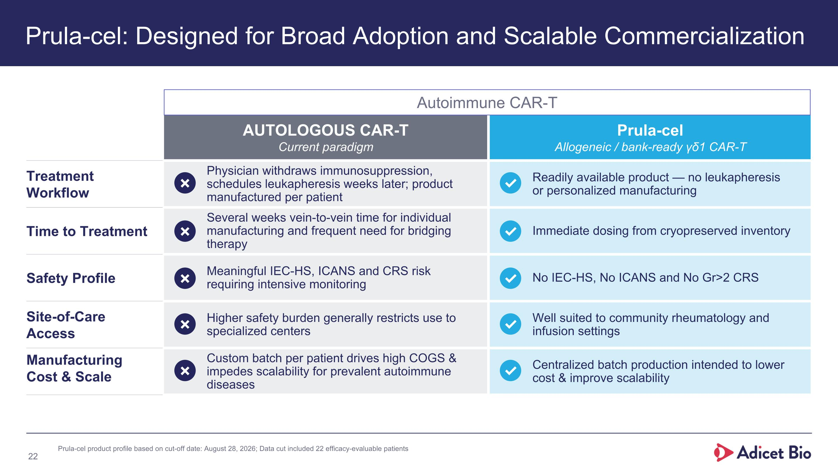
Prula-cel: Potentially First Off-the-Shelf, Easy to Administer, One-Time Therapy With Efficacy Comparable to Autologous CAR-T & Favorable Safety AUTOLOGOUS CAR-T Current paradigm Prula-cel Allogeneic / bank-ready γδ1 CAR-T Treatment ?Workflow Physician withdraws immunosuppression, schedules leukapheresis weeks later; product manufactured per patient Readily available product — no leukapheresis or personalized manufacturing Time to Treatment Several weeks vein-to-vein time for individual manufacturing and frequent need for bridging therapy Immediate dosing from cryopreserved inventory Safety Profile Meaningful IEC-HS, ICANS and CRS risk requiring intensive monitoring No IEC-HS, No ICANS and No Gr>2 CRS Site-of-Care ?Access Higher safety burden generally restricts use to specialized centers Well suited to community rheumatology and infusion settings Manufacturing ?Cost & Scale Custom batch per patient drives high COGS & impedes scalability for prevalent autoimmune diseases Centralized batch production intended to lower cost & improve scalability Prula-cel: Designed for Broad Adoption and Scalable Commercialization ✗ ✓ ✗ ✓ ✗ ✓ ✗ ✓ ✗ ✓ Autoimmune CAR-T Prula-cel product profile based on cut-off date: August 28, 2026; Data cut included 22 efficacy-evaluable patients 22

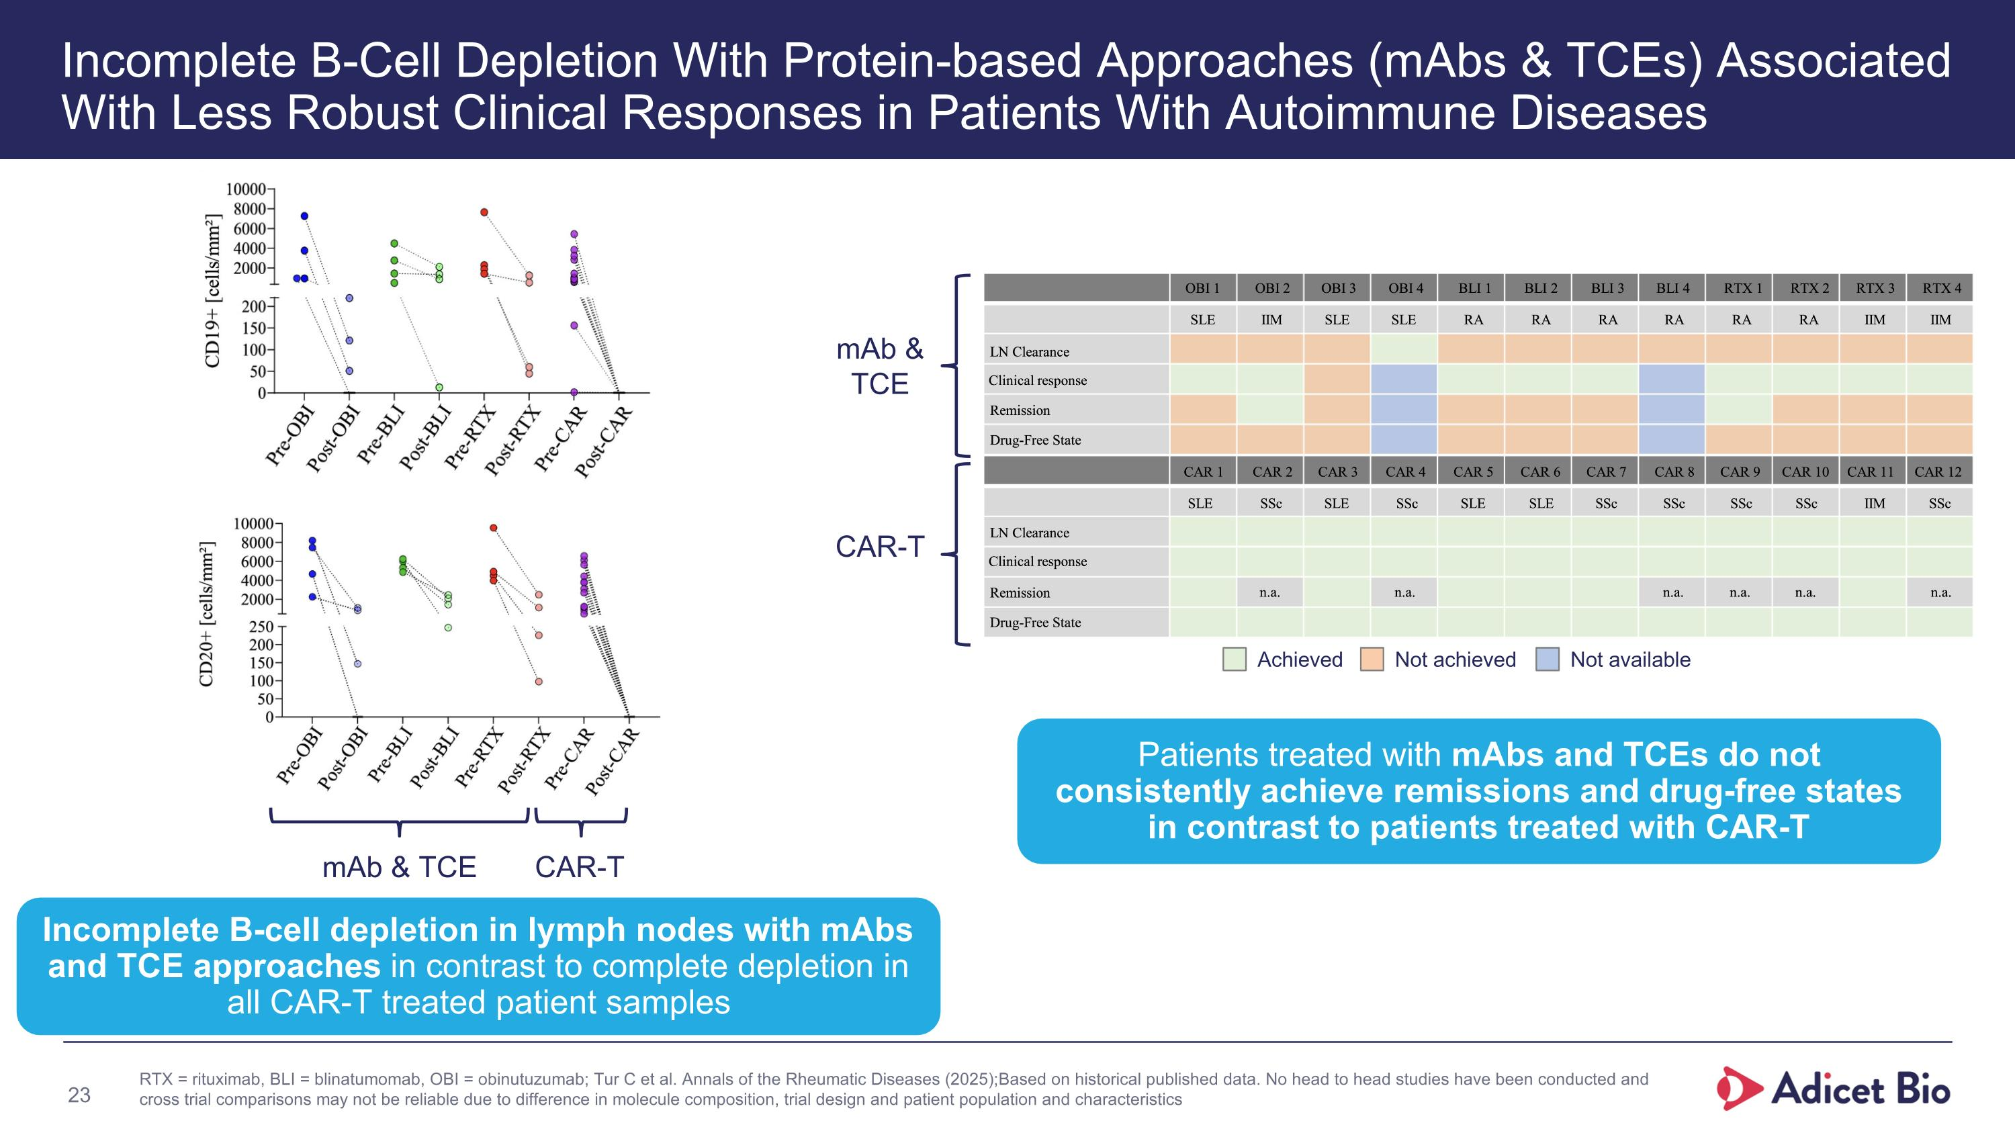
Incomplete B-Cell Depletion With Protein-based Approaches (mAbs & TCEs) Associated With Less Robust Clinical Responses in Patients With Autoimmune Diseases Incomplete B-cell depletion in lymph nodes with mAbs and TCE approaches in contrast to complete depletion in all CAR-T treated patient samples Patients treated with mAbs and TCEs do not consistently achieve remissions and drug-free states in contrast to patients treated with CAR-T mAb & TCE CAR-T mAb & TCE CAR-T Achieved Not achieved Not available RTX = rituximab, BLI = blinatumomab, OBI = obinutuzumab; Tur C et al. Annals of the Rheumatic Diseases (2025); Based on historical published data. No head to head studies have been conducted and cross trial comparisons may not be reliable due to difference in molecule composition, trial design and patient population and characteristics 23

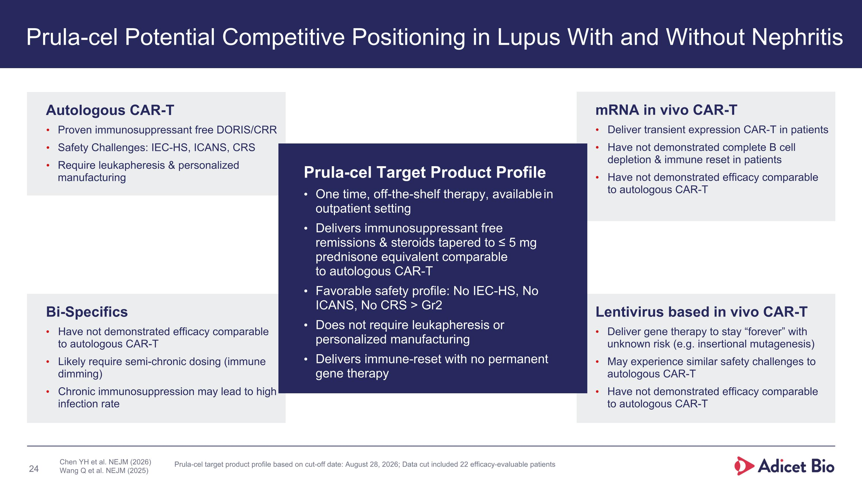
Prula-cel Potential Competitive Positioning in Lupus With and Without Nephritis Autologous CAR-T Proven immunosuppressant free DORIS/CRR Safety Challenges: IEC-HS, ICANS, CRS Require leukapheresis & personalized manufacturing Chen YH et al. NEJM (2026) Wang Q et al. NEJM (2025) Bi-Specifics Have not demonstrated efficacy comparable to autologous CAR-T Likely require semi-chronic dosing (immune dimming) Chronic immunosuppression may lead to high infection rate mRNA in vivo CAR-T Deliver transient expression CAR-T in patients Have not demonstrated complete B cell depletion & immune reset in patients Have not demonstrated efficacy comparable to autologous CAR-T Lentivirus based in vivo CAR-T Deliver gene therapy to stay “forever” with unknown risk (e.g. insertional mutagenesis) May experience similar safety challenges to autologous CAR-T Have not demonstrated efficacy comparable to autologous CAR-T Prula-cel Target Product Profile One time, off-the-shelf therapy, available in outpatient setting Delivers immunosuppressant free remissions & steroids tapered to ≤ 5 mg prednisone equivalent comparable ?to autologous CAR-T Favorable safety profile: No IEC-HS, No ICANS, No CRS > Gr2 Does not require leukapheresis or personalized manufacturing Delivers immune-reset with no permanent gene therapy Prula-cel target product profile based on cut-off date: August 28, 2026; Data cut included 22 efficacy-evaluable patients

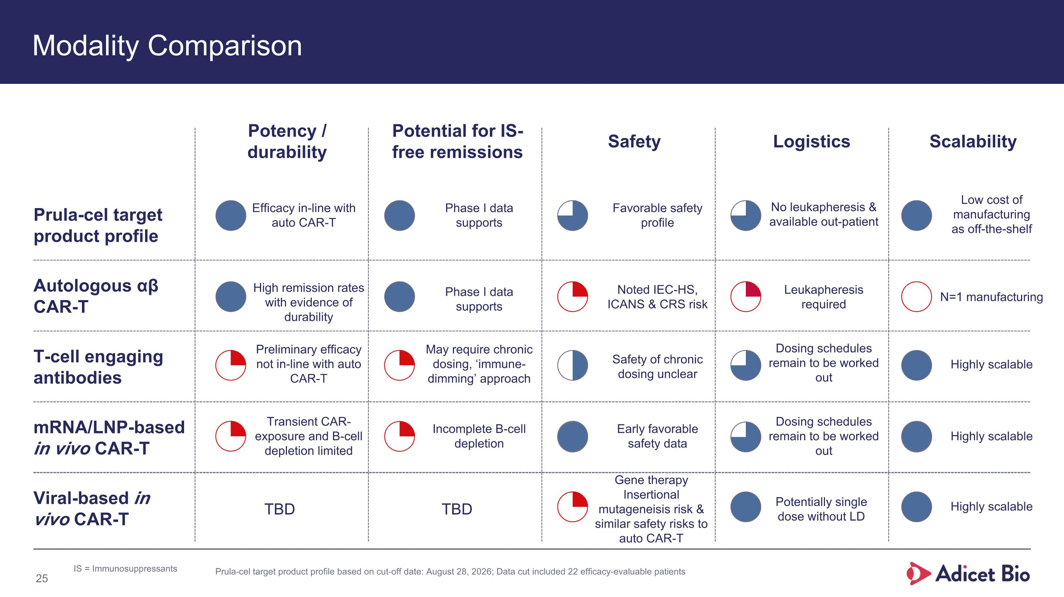
Modality Comparison 25 Prula-cel target product profile Autologous αβ CAR-T T-cell engaging antibodies mRNA/LNP-based in vivo CAR-T Viral-based in vivo CAR-T Potency / durability Safety Logistics Scalability Potential for IS-free remissions Efficacy in-line with auto CAR-T Favorable safety profile Noted IEC-HS, ICANS & CRS risk Leukapheresis required N=1 manufacturing No leukapheresis & available out-patient Phase I data supports Low cost of manufacturing as off-the-shelf May require chronic dosing, ‘immune-dimming’ approach Preliminary efficacy not in-line with auto CAR-T High remission rates with evidence of durability Transient CAR-exposure and B-cell depletion limited Gene therapy Insertional mutageneisis risk & similar safety risks to auto CAR-T Incomplete B-cell depletion Phase I data supports Safety of chronic dosing unclear TBD TBD Early favorable safety data Dosing schedules remain to be worked out Dosing schedules remain to be worked out Highly scalable Highly scalable Highly scalable IS = Immunosuppressants Potentially single dose without LD Prula-cel target product profile based on cut-off date: August 28, 2026; Data cut included 22 efficacy-evaluable patients

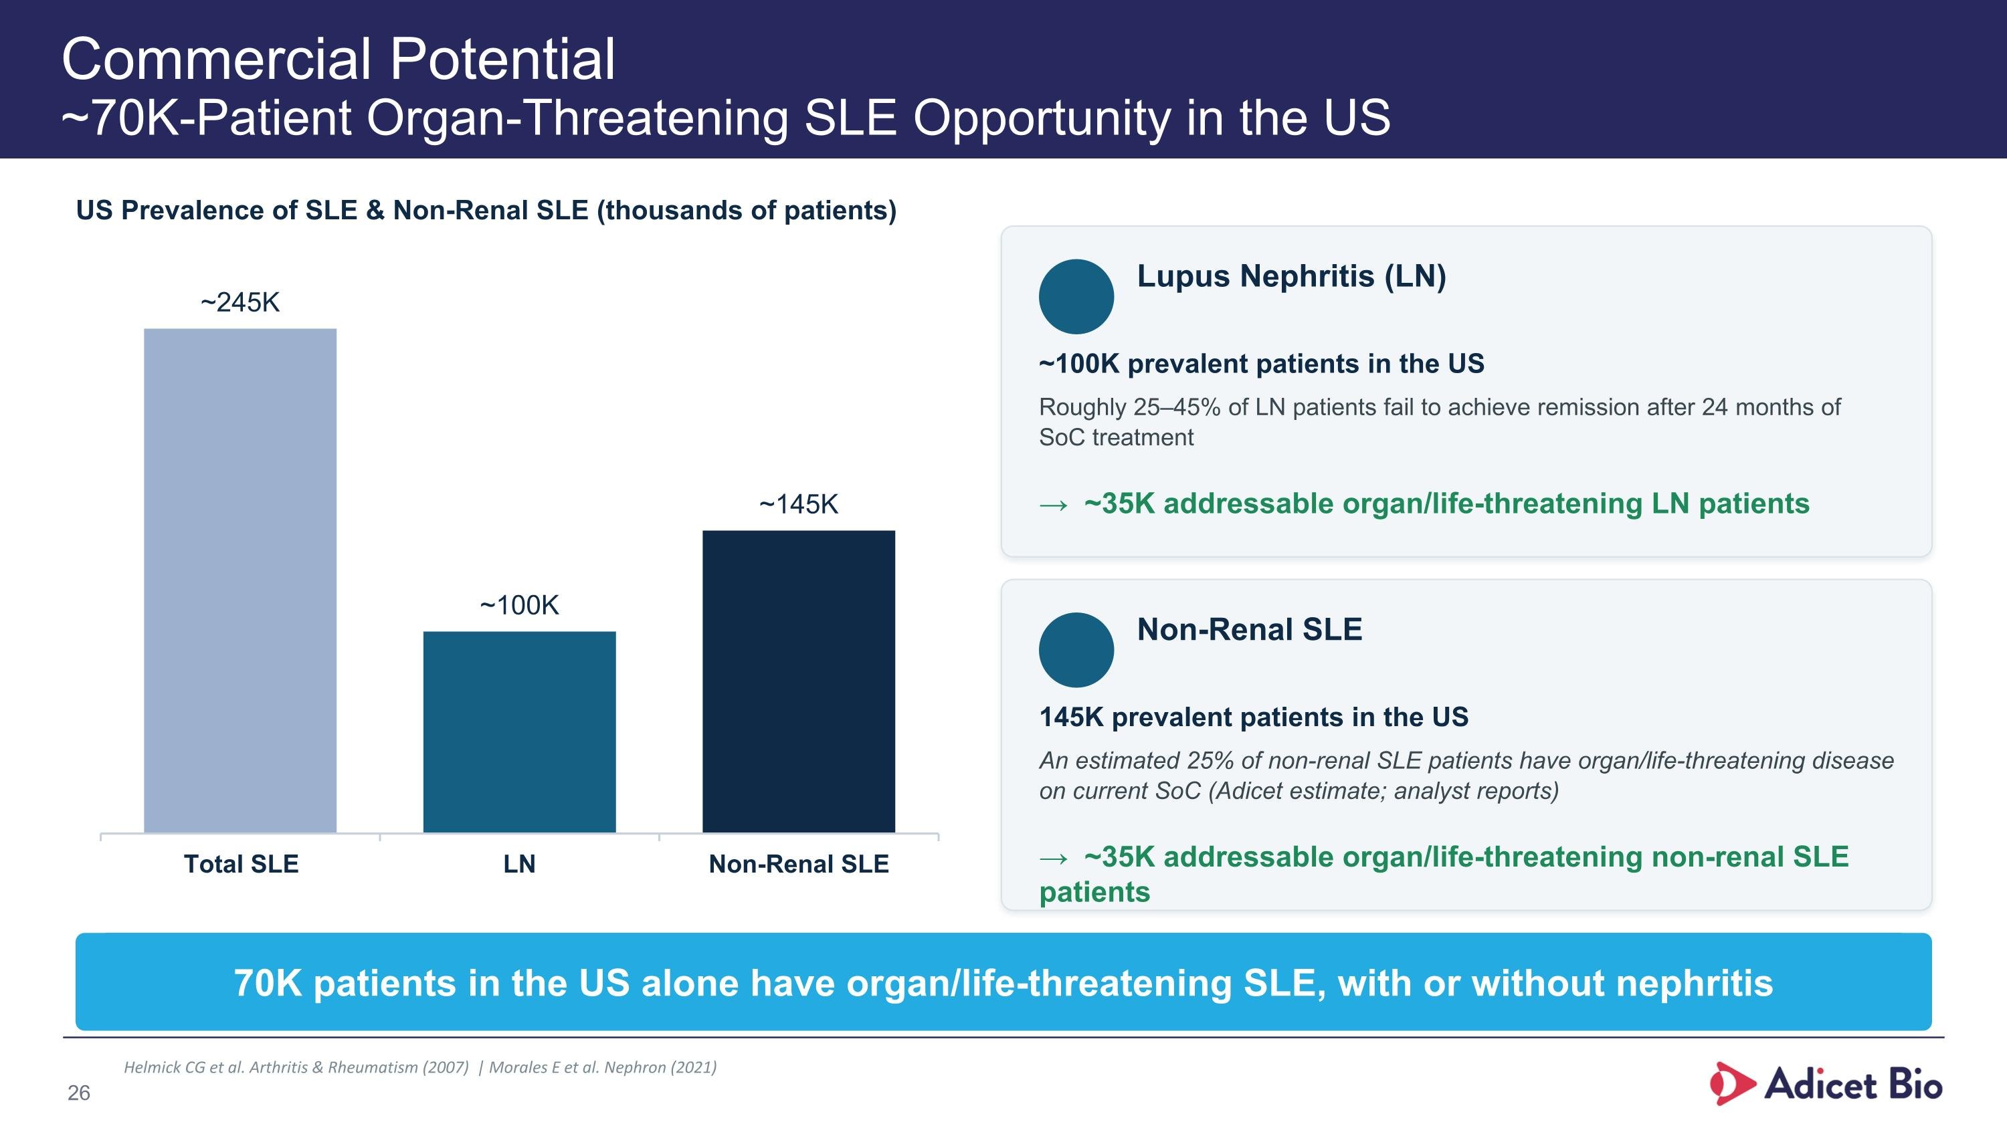
Commercial Potential?~70K-Patient Organ-Threatening SLE Opportunity in the US US Prevalence of SLE & Non-Renal SLE (thousands of patients) Lupus Nephritis (LN) ~100K prevalent patients in the US Roughly 25–45% of LN patients fail to achieve remission after 24 months of SoC treatment → ~35K addressable organ/life-threatening LN patients Non-Renal SLE 145K prevalent patients in the US An estimated 25% of non-renal SLE patients have organ/life-threatening disease on current SoC (Adicet estimate; analyst reports) → ~35K addressable organ/life-threatening non-renal SLE patients 70K patients in the US alone have organ/life-threatening SLE, with or without nephritis Helmick CG et al. Arthritis & Rheumatism (2007) | Morales E et al. Nephron (2021) 26

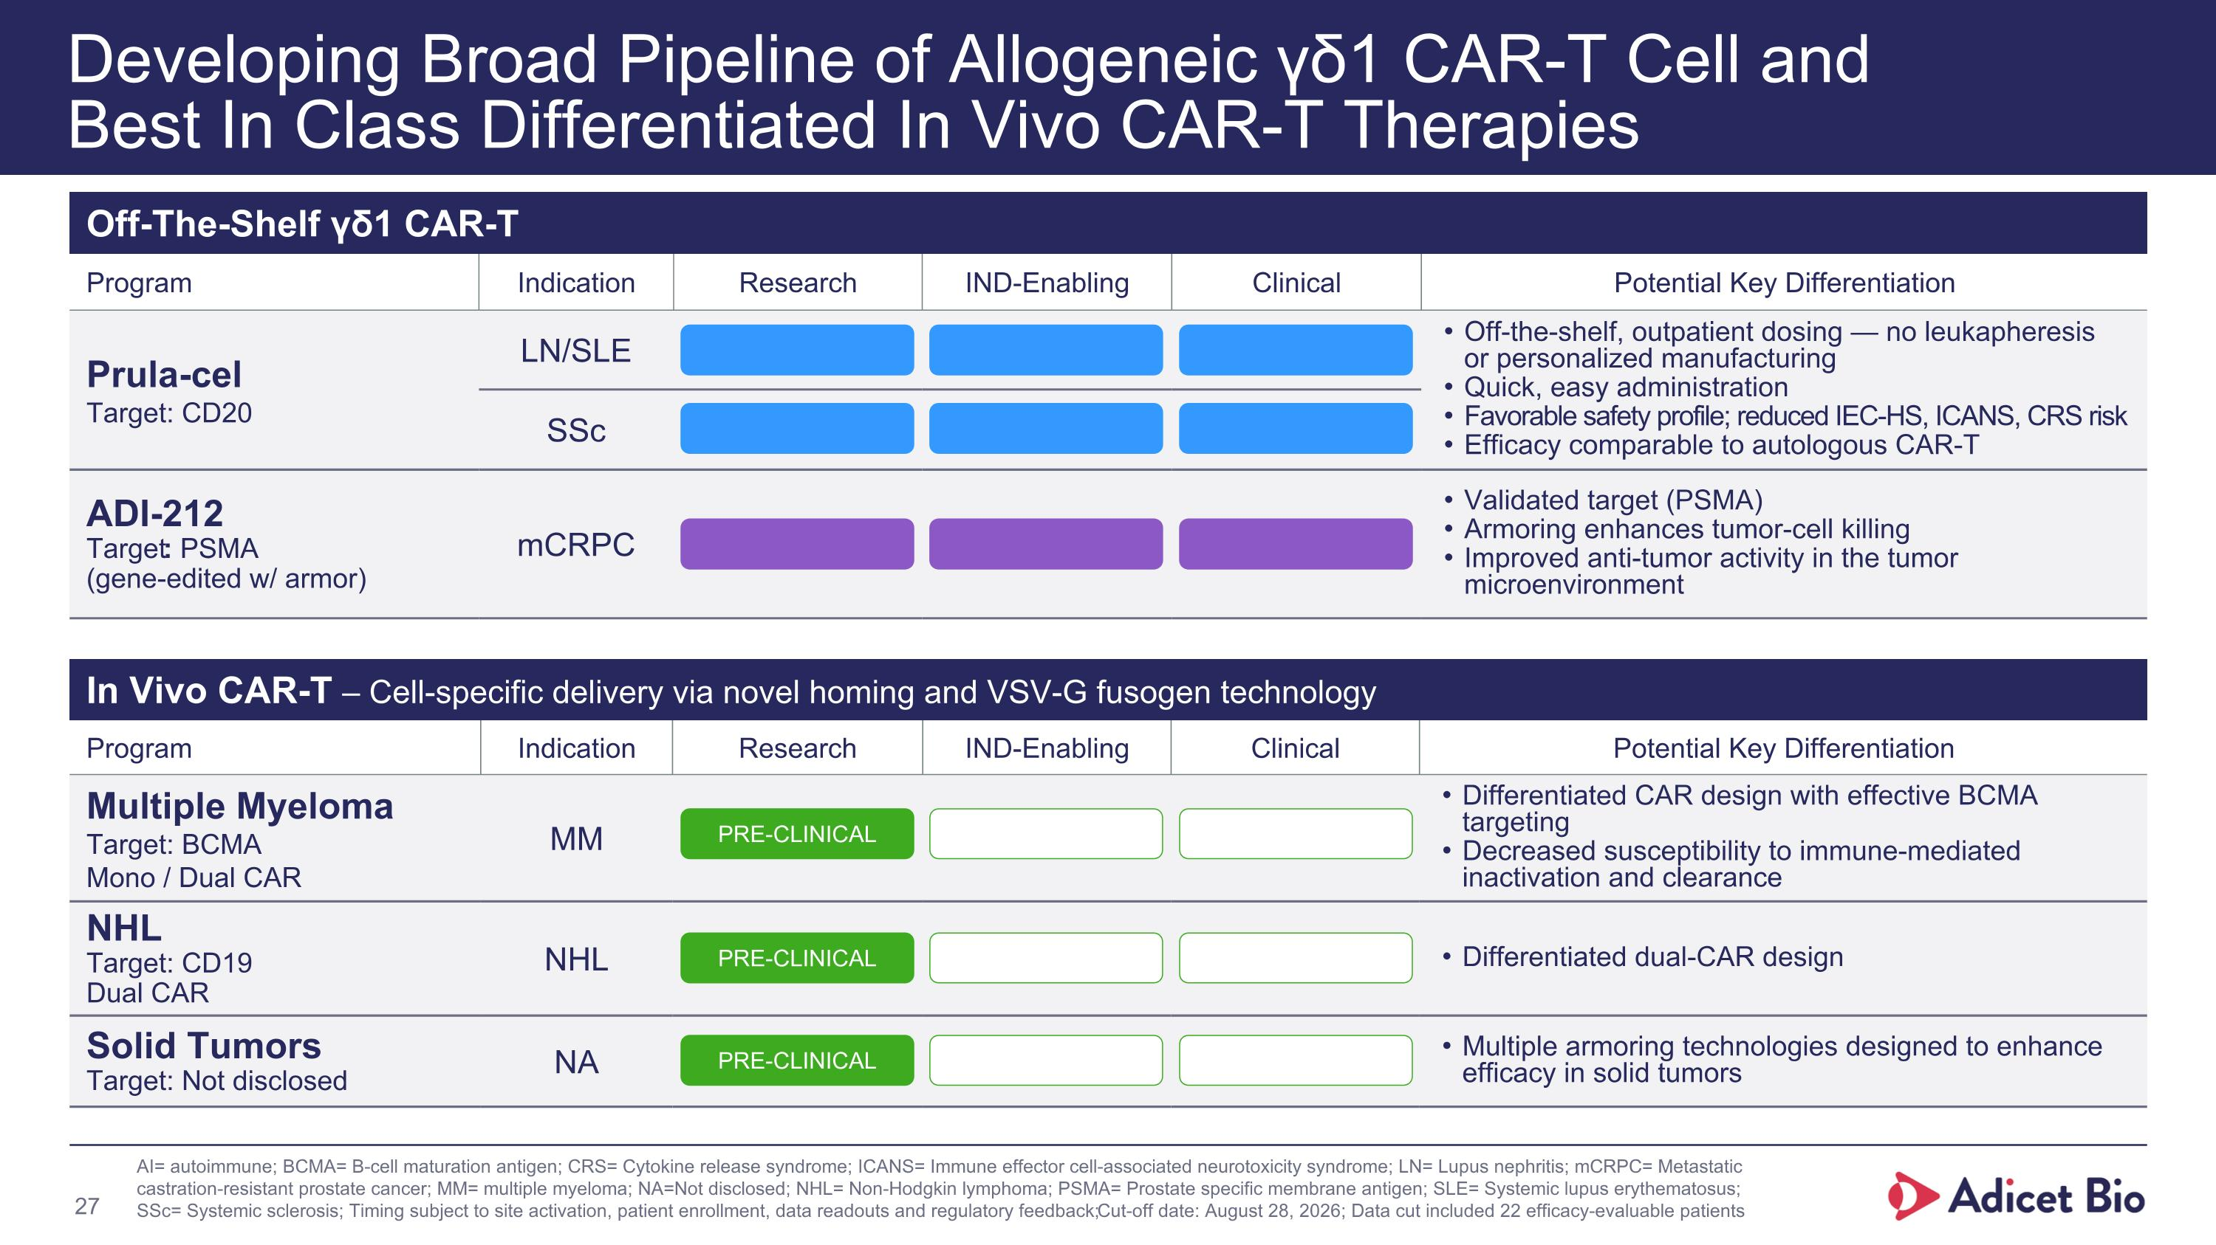
Program Indication Research IND-Enabling Clinical Potential Key Differentiation Prula-cel Target: CD20 LN/SLE Off-the-shelf, outpatient dosing — no leukapheresis ?or personalized manufacturing Quick, easy administration Favorable safety profile; reduced IEC-HS, ICANS, CRS risk Efficacy comparable to autologous CAR-T SSc ADI-212 Target: PSMA (gene-edited w/ armor) mCRPC Validated target (PSMA) Armoring enhances tumor-cell killing Improved anti-tumor activity in the tumor microenvironment Developing Broad Pipeline of Allogeneic γδ1 CAR-T Cell and Best In Class Differentiated In Vivo CAR-T Therapies Off-The-Shelf γδ1 CAR-T Program Indication Research IND-Enabling Clinical Potential Key Differentiation Multiple Myeloma Target: BCMA Mono / Dual CAR MM Differentiated CAR design with effective BCMA targeting Decreased susceptibility to immune-mediated inactivation and clearance NHL Target: CD19 Dual CAR NHL Differentiated dual-CAR design Solid Tumors Target: Not disclosed NA Multiple armoring technologies designed to enhance efficacy in solid tumors In Vivo CAR-T – Cell-specific delivery via novel homing and VSV-G fusogen technology PRE-CLINICAL PRE-CLINICAL PRE-CLINICAL AI= autoimmune; BCMA= B-cell maturation antigen; CRS= Cytokine release syndrome; ICANS= Immune effector cell-associated neurotoxicity syndrome; LN= Lupus nephritis; mCRPC= Metastatic castration-resistant prostate cancer; MM= multiple myeloma; NA=Not disclosed; NHL= Non-Hodgkin lymphoma; PSMA= Prostate specific membrane antigen; SLE= Systemic lupus erythematosus; SSc= Systemic sclerosis; Timing subject to site activation, patient enrollment, data readouts and regulatory feedback; Cut-off date: August 28, 2026; Data cut included 22 efficacy-evaluable patients 27

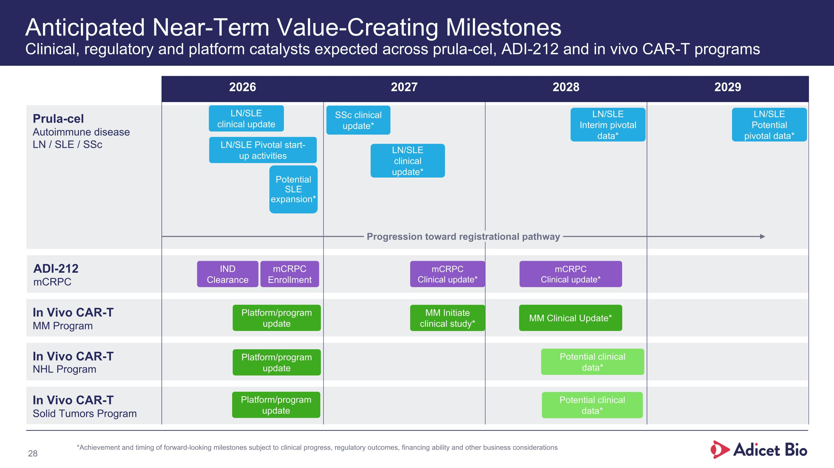
Anticipated Near-Term Value-Creating Milestones?Clinical, regulatory and platform catalysts expected across prula-cel, ADI-212 and in vivo CAR-T programs Prula-cel Autoimmune disease LN / SLE / SSc ADI-212 mCRPC In Vivo CAR-T MM Program In Vivo CAR-T NHL Program In Vivo CAR-T Solid Tumors Program 2026 2027 2028 2029 Progression toward registrational pathway Potential clinical data* Potential clinical data* MM Initiate clinical study* mCRPC Clinical update* SSc clinical update* LN/SLE clinical update LN/SLE clinical update* LN/SLE Pivotal start-up activities mCRPC Enrollment Potential SLE expansion* IND Clearance LN/SLE Interim pivotal data* LN/SLE Potential pivotal data* *Achievement and timing of forward-looking milestones subject to clinical progress, regulatory outcomes, financing ability and other business considerations Platform/program update Platform/program update Platform/program update MM Clinical Update* mCRPC Clinical update*

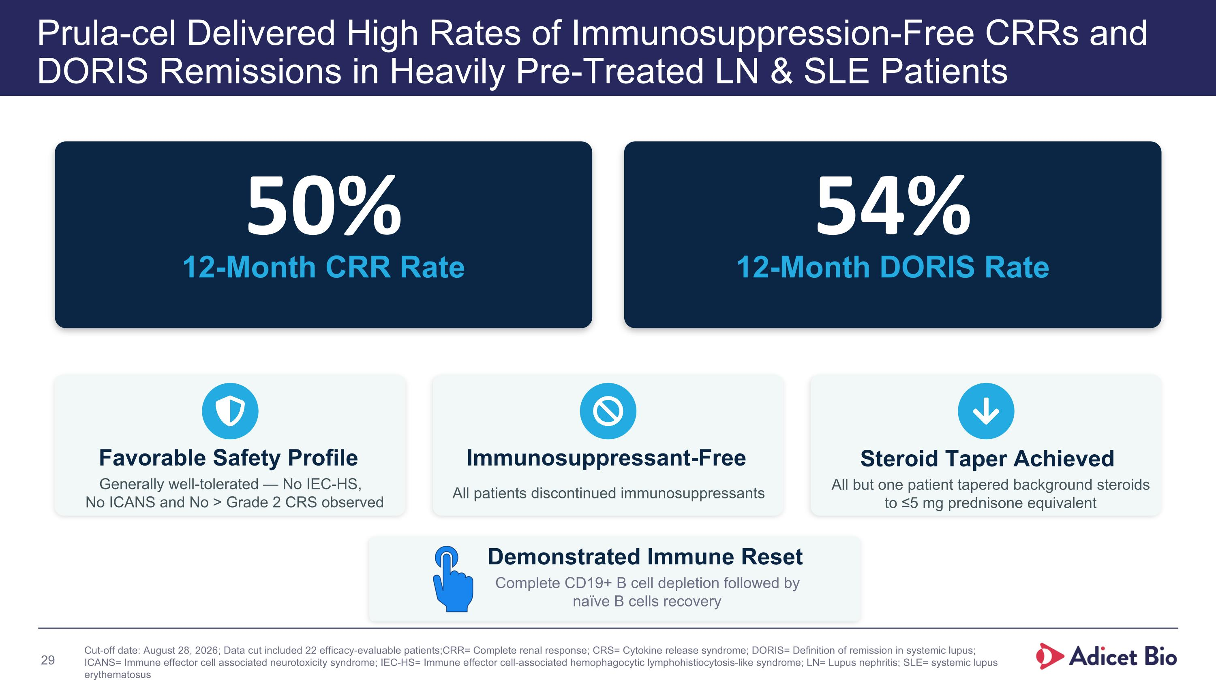
Prula-cel Delivered High Rates of Immunosuppression-Free CRRs and DORIS Remissions in Heavily Pre-Treated LN & SLE Patients 50% 12-Month CRR Rate 54% 12-Month DORIS Rate Favorable Safety Profile Generally well-tolerated — No IEC-HS, No ICANS and No > Grade 2 CRS observed Immunosuppressant-Free All patients discontinued immunosuppressants Steroid Taper Achieved All but one patient tapered background steroids to ≤5 mg prednisone equivalent Cut-off date: August 28, 2026; Data cut included 22 efficacy-evaluable patients; CRR= Complete renal response; CRS= Cytokine release syndrome; DORIS= Definition of remission in systemic lupus; ICANS= Immune effector cell associated neurotoxicity syndrome; IEC-HS= Immune effector cell-associated hemophagocytic lymphohistiocytosis-like syndrome; LN= Lupus nephritis; SLE= systemic lupus erythematosus Demonstrated Immune Reset Complete CD19+ B cell depletion followed by naïve B cells recovery



