UNITED STATES
SECURITIES AND EXCHANGE COMMISSION
Washington, D.C. 20549
SCHEDULE 14A INFORMATION
Proxy Statement Pursuant to Section 14(a) of the
Securities Exchange Act of 1934
(Amendment No. )
Filed by the Registrant ☒ | Filed by a Party other than the Registrant ☐
Check the appropriate box:
☐ Preliminary Proxy Statement
☐ Confidential, for Use of the Commission Only (as permitted by Rule 14a-6(e)(2))
☐ Definitive Proxy Statement
☒ Definitive Additional Materials
☐ Soliciting Material under §240.14a-12
Adicet Bio, Inc.
(Name of Registrant as Specified in its Charter)

(Name of Person(s) Filing Proxy Statement, if other than the Registrant)
Payment of Filing Fee (Check all boxes that apply):
☒ | No fee required
☐ | Fee paid previously with preliminary materials
☐ | Fee computed on table in exhibit required by Item 25(b) per Securities Exchange Act Rules 14a-6(i)(1) and 0-11

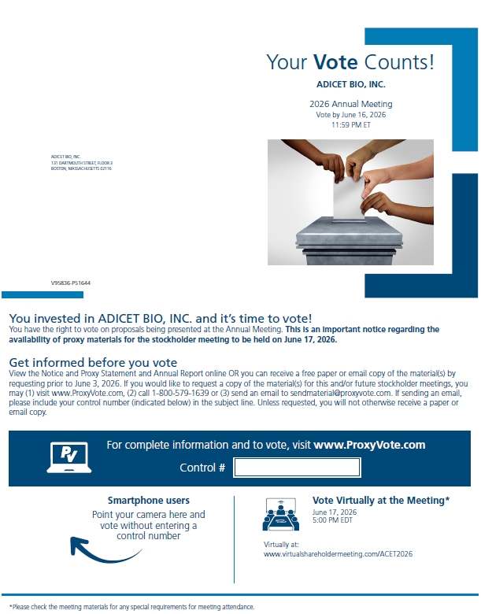
Your Vote Counts! ADICET BIO, INC. 2026 Annual Meeting Vote by June 16, 2026 11:59 PM ET ADICET BIO, INC. 131 DARTMOUTH STREET, FLOOR 3 BOSTON, MASSACHUSETTS 02116 V95836-P51644 You invested in ADICET BIO, INC. and it’s time to vote! You have the right to vote on proposals being presented at the Annual Meeting. This is an important notice regarding the availability of proxy materials for the stockholder meeting to be held on June 17, 2026. Get informed before you vote View the Notice and Proxy Statement and Annual Report online OR you can receive a free paper or email copy of the material(s) by requesting prior to June 3, 2026. If you would like to request a copy of the material(s) for this and/or future stockholder meetings, you may (1) visit www.ProxyVote.com, (2) call 1-800-579-1639 or (3) send an email to sendmaterial@proxyvote.com. If sending an email, please include your control number (indicated below) in the subject line. Unless requested, you will not otherwise receive a paper or email copy. For complete information and to vote, visit www.ProxyVote.com Control # Smartphone users Point your camera here and vote without entering a control number Vote Virtually at the Meeting* June 17, 2026 5:00 PM EDT Virtually at: www.virtualshareholdermeeting.com/ACET2026 *Please check the meeting materials for any special requirements for meeting attendance.

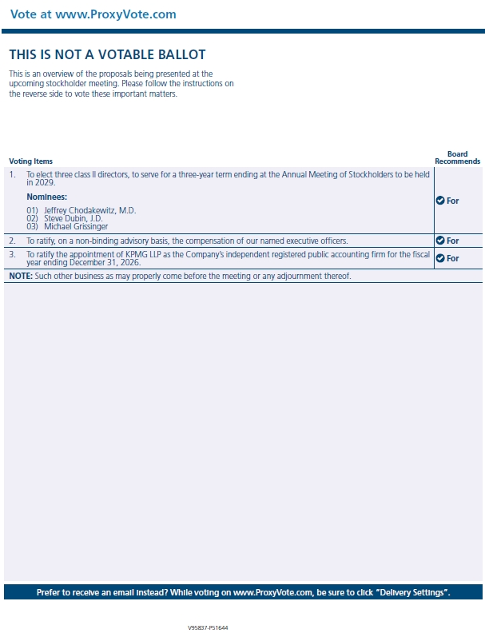
THIS IS NOT A VOTABLE BALLOT This is an overview of the proposals being presented at the upcoming stockholder meeting. Please follow the instructions on the reverse side to vote these important matters. Voting Items Board Recommends 1. To elect three class II directors, to serve for a three-year term ending at the Annual Meeting of Stockholders to be held in 2029. Nominees: For 01) Jeffrey Chodakewitz, M.D. 02) Steve Dubin, J.D. 03) Michael Grissinger 2. To ratify, on a non-binding advisory basis, the compensation of our named executive officers. For 3. To ratify the appointment of KPMG LLP as the Company’s independent registered public accounting firm for the fiscal year ending December 31, 2026. For NOTE: Such other business as may properly come before the meeting or any adjournment thereof. Prefer to receive an email instead? While voting on www.ProxyVote.com, be sure to click “Delivery Settings”.

